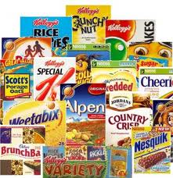
Cereal Box Project
The idea behind this project is for you to create a cereal box to sell in stores. You will have to look at many real-life factors that go into designing and producing a good marketable product. Throughout the course of this project, you will have to make decisions about the material that goes into making your cereal and the design of the cereal itself. Your container must be a Prism.
The project breaks down into three tasks:
- TASK 1: Creating your cereal box
- TASK 2: Calculating SURFACE AREA
- TASK 3: Calculating VOLUME
TASK 1: CREATING YOUR CEREAL BOX (5 points)
You are to create a prism-shaped cereal box.
1. Name your figure and illustrate how it looks in “net form”. Draw the “net form” on a separate sheet of paper.
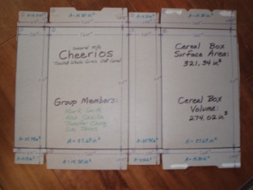(here’s an example of “net form.”)
2. How many vertices does your figure have?

3. How many lateral faces does your figure have?

4. How many bases does your figure have?

TASK 2: CALCULATING SURFACE AREA (5 points)
**Use centimeters for all of your measuring and calculations!!**
1. Measure the height of your prism and record - h = ____________________
2. Measure the dimensions of your prism’s base and record - l = ____________________
“base height”$→$ w = ____________________
3. Calculate the area of your prism’s base, showing all work!

A = ____________________
4. Use the appropriate formula to calculate your prism’s SURFACE AREA.

SA = ____________________

TASK 3: CALCULATING THE VOLUME (5 points)
**Use centimeters for all of your measuring and calculations!!**
1. Using the measurements from TASK 2 and showing all work, use the appropriate formula to calculate the VOLUME of your cereal box.

V = ____________________

