**Chapter 10 Practice Quiz 1**

Find the volume of each prism

1. 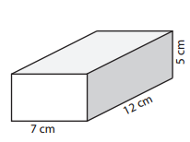
2. 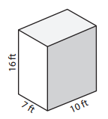
3. 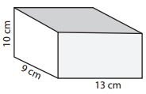
4. 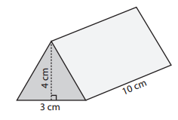
5. 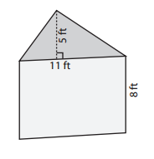
6. 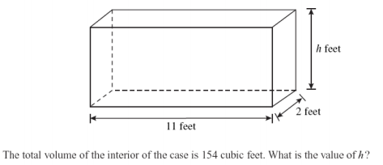

Find the surface area of each prism

7. 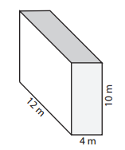

8. 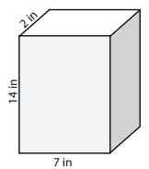

9. For a rectangular prism that is 7 feet by 6 feet by 4 feet

* 1. Find the volume
  2. Find the surface area