Chapter 10 Practice Test
Find the volume of each prism

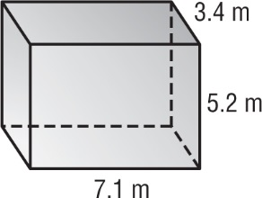

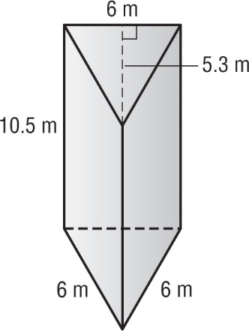

Find the surface area of each figure

- 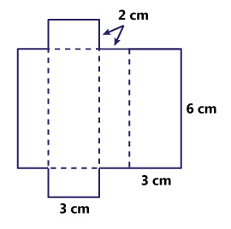

- 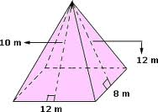

- 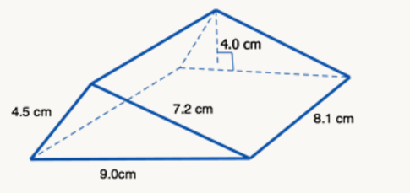

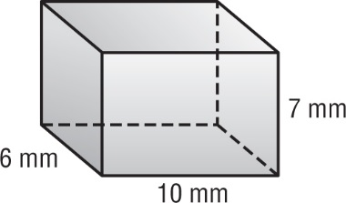

- 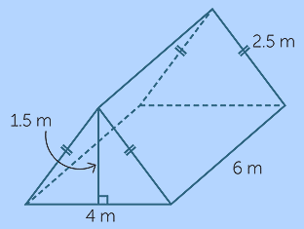

- A gift box in the shape of a triangular prism has a volume of 35 cubic inches, a base height of 5 inches, and a height of 2 inches. What is the length of the base?

- A special box designed to hold an antique artifact is shaped like a triangular prism. The surface area of the box is 121.2 square inches. The height of the base triangle is 5.2 inches and each side of the base triangle is 6 inches long. What is the height of box? (3 points)

- A room is 15 feet long, 25 feet wide, and 20 feet tall. If Mickey paints the walls and the ceiling, how much surface area will he cover?

- A pyramid has all sides that are equilateral triangles. Each triangle has side lengths of 8 centimeters. If the surface area of the pyramid is 67.2 square centimeters, what is the slant height of the pyramid?
(3 points)

