Chapter 11 Practice Quiz

For Exercises 1 and 2, use the dot plot which shows the number of snakes in a zoo.

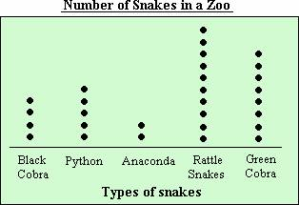

1. What is the range of the data?

2. Find the mean, median, and mode.

Find the mean for each set of data.

3. cost of tennis shoes: $54, $67, $61, $53, $65

4. ages of students’ dogs: 7, 4, 2, 3, 9, 11, 7

5. weights of cats at a pet store in pounds: 3, 11, 9, 5, 8

6. cost of DVDs: $10, $5, $19, $25, $15

For Exercises 7-9, use the following set of data.

TEMPERATURE The temperature in Georgia was recorded for 6 days in November.
The temperatures were 65°, 61°, 70°, 76°, 70°, and 62°.

7. What is the mean for the data?

8. What is the median for the data?

9. What is the mode for the data?

1._______________

2. _______________

3. _______________

4. _______________

5. _______________

6. _______________

7. _______________

8. _______________

9. _______________

