Chapter 12 Practice Test SCORE ____________

Write the letter for the correct answer in the blank at the right of each question.
1. Which of the following is an appropriate display to show interest rates over the past 3 weeks?
A. bar graph B. line graph C. circle graph D. histogram

2. Which of the following is an appropriate display to show the heights of adults arranged by intervals?
F. bar graph G. line graph H. circle graph I. histogram

For Exercises 3-4, use the box plot. It shows the number of days on the market for single family homes in a city.
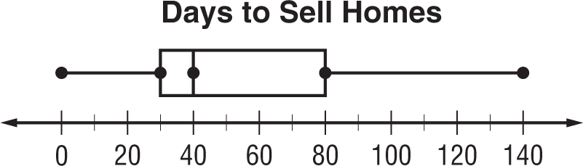

3. What are the third and first quartiles of the data?
A. 40, 30 C. 140, 0
B. 140, 80 D. 80, 30

4. What percent of homes were on the market between 40 and 140 days?
F. 25% G. 50% H. 75% I. 100%

For Exercises 5-7, use the line plot below. It shows the number of cans collected by the student council.
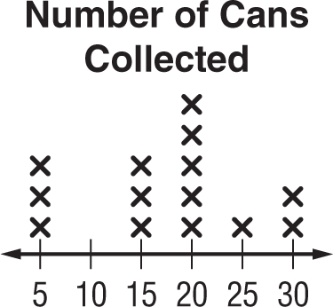

5. What is the mean of the data?
A. 15 B. 17.5 C. 22.5 D. 25

6. Which of the following describes the shape of the data distribution?
F. There is a peak at 15. H. There is a gap from 25-30.
G. There is a cluster from 5-15. I. It is not symmetric.

7. Which of the following describes the data?
A. symmetric C. peak at 15
B. not symmetric D. cluster at 10

1. ____________

2. ____________

3. ____________

4. ____________

5. ____________

6. ____________

7. ____________

Test, Form 1B (continued) SCORE ____________

For Exercises 8 and 9, use the line plot that shows the number of times students went to the pool in June.
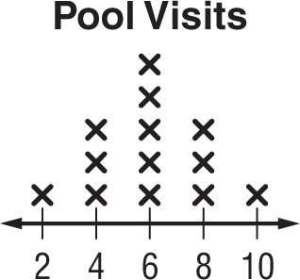

8. Which of the following is true?
F. the data is not symmetric H. no gaps
G. peak at 4 I. no mode

9. Which would you use to describe the spread of the data?
A. clusters C. range
B. interquartile range I. mean absolute deviation

For Exercises 10 and 11, refer to the histogram.
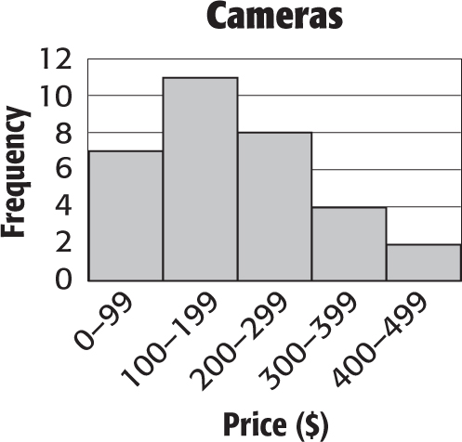

10. How many cameras cost less than $100?
F. 2 G. 7 H. 8 I. 18

11. Which price range has the least frequency?
A. $0–$99 C. $100–$199
B. $300–$399 D. $400–$499

12. The graph shows test scores of students with various grade point averages. What is the best prediction of a student with a grade point average of 3.25?
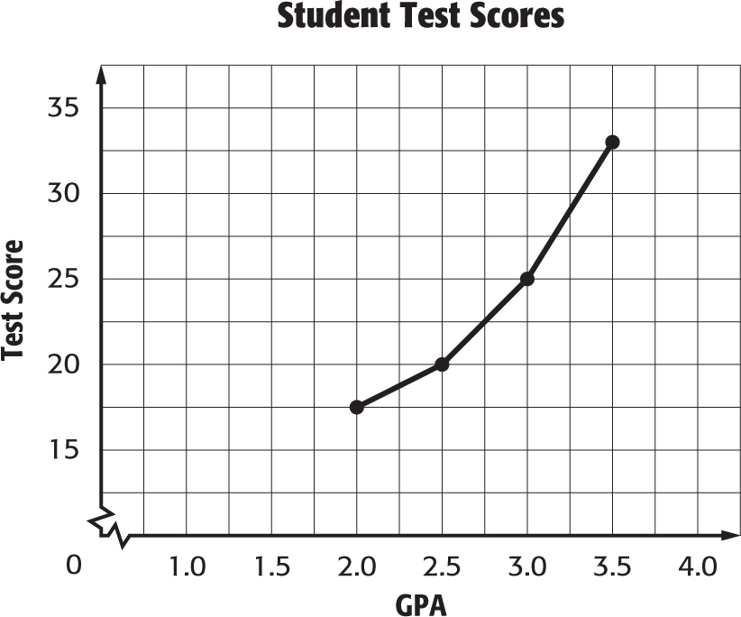
F. 34
G. 32
H. 29
I. 25

8. ____________

9. ____________

10. ___________

11. ___________

12. ___________

