Chapter Quiz Practice

For Exercises 1 and 2 use the line plot.
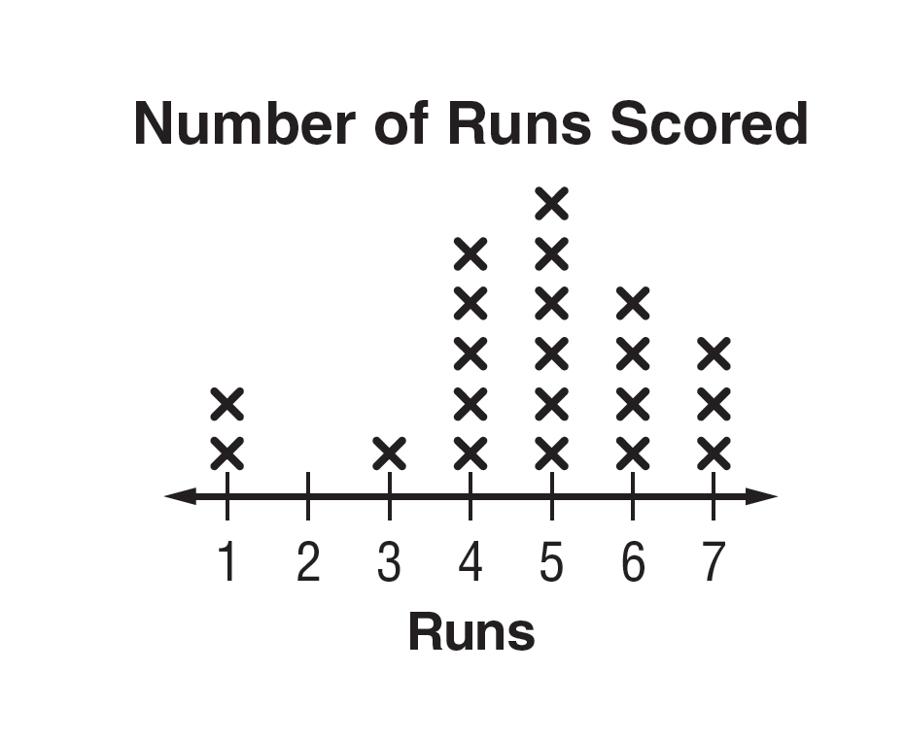

1. Use the line plot. What is the mode of the data?

2. Compare the number of most runs scored to the number of least amount of runs.

EARTHQUAKES For Exercises 3 and 4, use the table.
Major Earthquakes
Magnitude | Frequency
7.0 –7.3 | 1
7.4 –7.7 | 4
7.8 – 8.1 | 6
8.2 – 8.5 | 2

3. Describe the data in the table.

4. Draw a histogram to represent the frequency of each interval.

COMPUTER The table shows the cost of several computers.
Cost of Computer ($)
600, 1300, 1,040, 1,320, 999, 800, 2500,
2,100, 2175, 465, 1150, 1,200, 1,599, 1,585

5. Find the range of the data.

6. Find the third and first quartiles.

7. Find any outliers of the data.

8. Draw a box plot to show this data.

1. _____________________

2. _____________________

3. _____________________

4. _____________________

5. _____________________

6. _____________________

7. _____________________

8.

