**Chapter 9 Practice Test**

Find the area of each figure

1. 

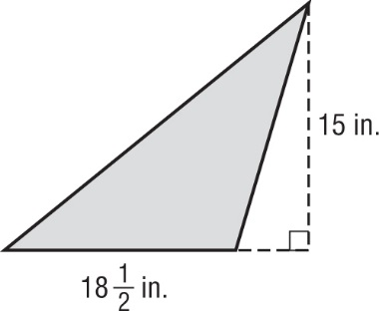

1. 
2. 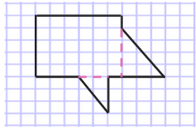
3. The figure below shows the dimensions of the local dog park. What is the area of the dog park?

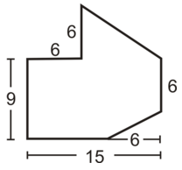

1. Find the area of the shaded region

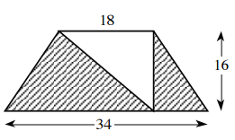

1. A triangle has a base of 35 feet and an area of 385 square feet.   
   What is the height of the triangle?
2. Suppose the base, height, and sides of the parallelogram are multiplied by 5.
   1. Find its original parameter and the new parameter.

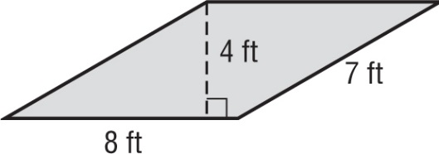

* 1. Find its original area and the new area.
  2. How are the values of the old and new parameters different? Briefly explain

How are the values of the old and new area different? Briefly explain

1. Find the base of a parallelogram with height 17 yards and an area of 255 square yards.
2. Find the area of the figure

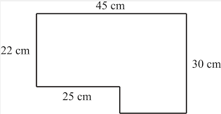

1. A figure has vertices *W*(2, 1), *X*(4, 5), *Y*(7, 5), and *Z*(5, 1).
   1. Graph the figure and state what type of a figure it is

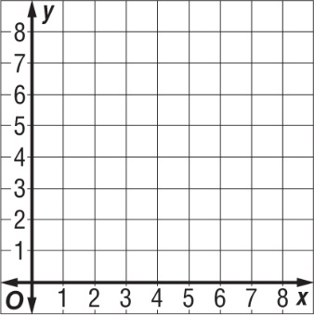

* 1. Find the area of the figure