Practice Final

Find the value of each expression

- 17 + (9 $-$6) × $3^{3}$

- 8 + 6 × 4 ÷ $2^{3}$

Define each variable. Then write each phrase as an algebraic expression

- 20 minutes faster than Jarod’s time

- Two thirds the amount of salt

Give an example of each of the following properties

- associative

- commutative

- distributive

- Simplify 7x + 2(5 $-$ 3x)

Solve each equation

- y $+\frac{2}{3}=\frac{1}{6}$

- c − 24 = 75

- 14g = 238

- 41 = $\frac{h}{13}$

- Fred is making a bouquet of carnations and roses. The carnations cost $4.37 in all. The roses cost $1.34 each. How many roses did Fred use if the bouquet cost $12.41 in all?

Find the rule for each function table

Input  (x) | Output  (y)
2 | 5
5 | 17
7 | 25

Input  (x) | Output  (y)
8 | 2
24 | 6
36 | 9

Solve and graph each inequality

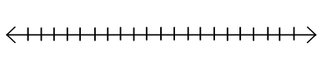
- d $-$ 13 > 18

- 3x $≤$ 75

- Graph the equation y = $\frac{1}{3}$ x + 4

Find the area of each figure

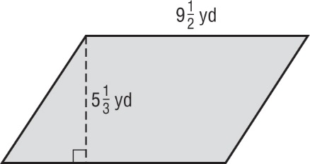

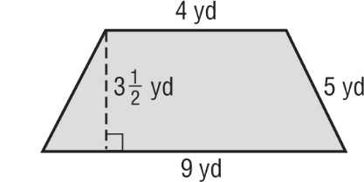

- 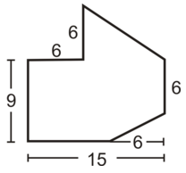

Find the volume of each figure
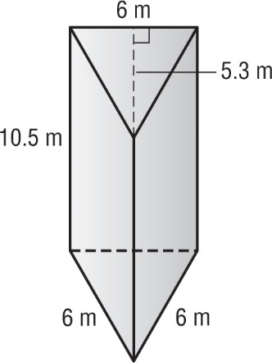

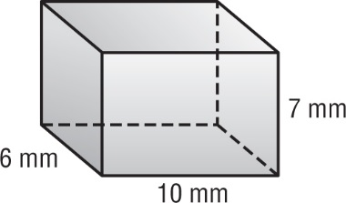

Find the surface area

- 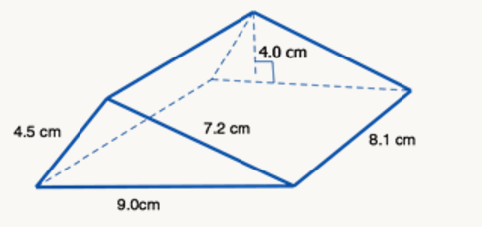

Find the mean, median, mode, range, first and third quartiles, and the interquartile range

Number of CDs
12 | 10 | 21 | 7 | 2 | 17
5 | 8 | 12 | 0 | 0 | 16
18 | 0 | 20 | 13 | 5 | 16

- Serge had the following scores on his math tests last quarter: 91, 87, 89, 82, 100, 81, 92, and 72. Find the mean absolute deviation for the set of data. How many data values are closer than one mean absolute deviation away from the mean?

When preparing for the test, please consider the following.
- You will be allowed one page of notes.
- Calculators will NOT be allowed during the actual final.
- Your final for 6th grade math will be on Tuesday, May 30th , from 10:30-12:00 a.m.
- This study guide will be DUE, completed, on the day of the final. It will be considered homework, worth 10 points!

