9-1 Study Guide and Intervention
Graphing Quadratic Functions

Characteristics of Quadratic Functions
Quadratic  Function | a function described by an equation of the form f(x) = a$x^{2}$ + bx + c,  where a ≠ 0 | Example:  y = 2$x^{2}$ + 3x + 8
The parent graph of the family of quadratic functions is y = $x^{2}$. Graphs of quadratic functions have a general shape called a parabola. A parabola opens upward and has a minimum point when the value of a is positive, and a parabola opens downward and has a maximum point when the value of a is negative.

Example 1:
a. Use a table of values to graph y = $x^{2}$ – 4x + 1.
x | 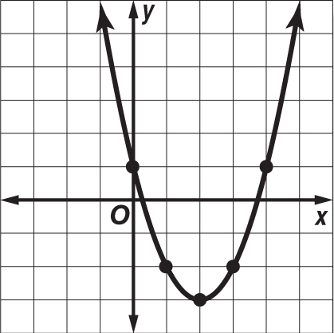  y
–1 | 6
0 | 1
1 | –2
2 | –3
3 | –2
4 | 1

Graph the ordered pairs in the table and connect them with a smooth curve.

b. What are the domain and range of this function?
The domain is all real numbers. The range is all real numbers greater than or equal to –3, which is the minimum.

Example 2:
a. Use a table of values to graph y = –$x^{2}$– 6x – 7.
x | 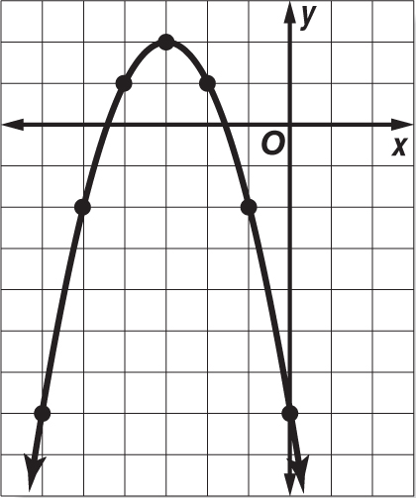  y
–6 | –7
–5 | –2
–4 | 1
–3 | 2
–2 | 1
–1 | –2
0 | –7

Graph the ordered pairs in the table and connect them with a smooth curve.

b. What are the domain and range of this function?
The domain is all real numbers. The range is all
real numbers less than or equal to 2, which is the maximum.

Exercises
Use a table of values to graph each function. Determine the domain and range.
1. y = $x^{2}$ + 2 2. y = –$x^{2}$ – 4 3. y = $x^{2}$ – 3x + 2
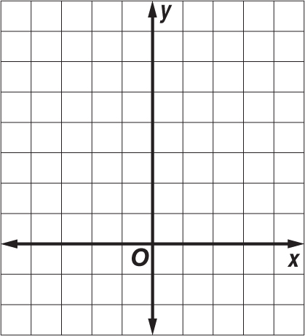
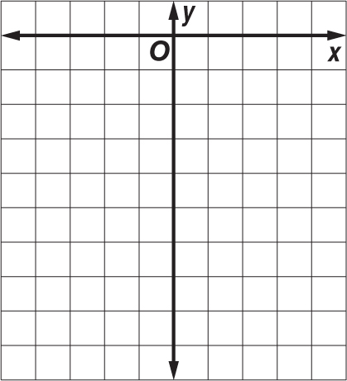
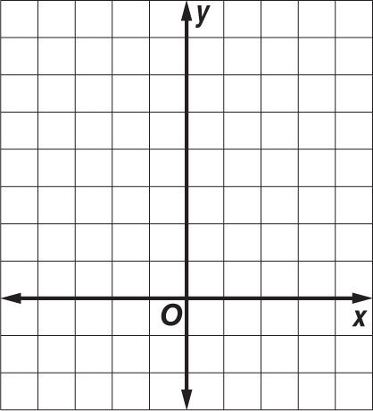

9-1 Study Guide and Intervention (continued)
Graphing Quadratic Functions

Symmetry and Vertices Parabolas have a geometric property called symmetry. That is, if the figure is folded in half, each half will match the other half exactly. The vertical line containing the fold line is called the axis of symmetry. The axis of symmetry contains the minimum or maximum point of the parabola, the vertex.
Axis of  Symmetry | For the parabola y = a$x^{2}$ + bx + c, where a ≠ 0, the line x = – $\frac{b}{2a}$  is the axis of symmetry. | Example: The axis of symmetry of  y = $x^{2}$ + 2x + 5 is the line x = –1.

Example : Consider the graph of y = 2$x^{2}$ + 4x + 1.

a. Write the equation of the axis of symmetry.
In y = 2$x^{2}$ + 4x + 1, a = 2 and b = 4.
Substitute these values into the equation of the
axis of symmetry.
x = – $\frac{b}{2a}$
x = – $\frac{4}{2(2)}$
= –1
The axis of symmetry is x = –1.

b. Find the coordinates of the vertex.
Since the equation of the axis of symmetry is x = –1 and the vertex lies on the axis, the x–coordinate of the vertex is –1.
y = 2$x^{2}$ + 4x + 1 Original equation
y = 2${(-1)}^{2}$ + 4(–1) + 1 Substitute.
y = 2(1) – 4 + 1 Simplify.
y = –1
The vertex is at (–1, –1).

c. Identify the vertex as a maximum or a minimum.
Since the coefficient of the $x^{2}$-term is positive, the parabola opens upward, and the vertex is a minimum point.
d. Graph the function.
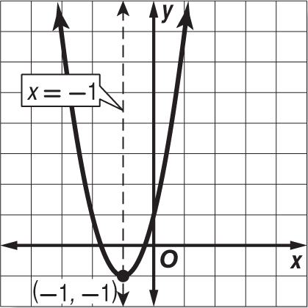

Exercises
Consider each equation. Determine whether the function has maximum or minimum value. State the maximum or minimum value and the domain and range of the function. Find the equation of the axis of symmetry. Graph the function.
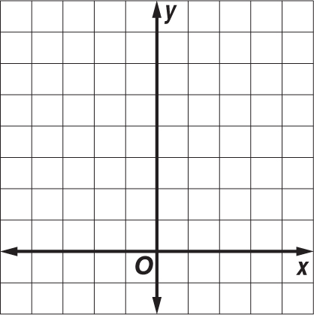
1. y = $x^{2}$ + 3 2. y = –$x^{2}$ – 4x – 4 3. y = $x^{2}$ + 2x + 3
