9-3 Study Guide and Intervention
Transformations of Quadratic Functions

Translations A translation is a change in the position of a figure either up, down, left, right, or diagonal.
Adding or subtracting constants in the equations of functions translates the graphs of the functions.
The graph of g(x) = $x^{2}$ + k translates the graph of f(x) = $x^{2}$ vertically.
If k > 0, the graph of f(x) = $x^{2}$ is translated k units up.
If k < 0, the graph of f(x) = $x^{2}$ is translated $\left|k\right|$ units down.

The graph of g(x) = ${(x-h)}^{2}$ is the graph of f(x) = $x^{2}$ translated horizontally.
If h > 0, the graph of f(x) = $x^{2}$ is translated h units to the right.
If h < 0, the graph of f(x) = $x^{2}$ is translated $\left|h\right|$ units to the left.

Example: Describe how the graph of each function is related to the graph of f(x) = $x^{2}$.le

a. g(x) = $x^{2}$ + 4
The value of k is 4, and 4 > 0. Therefore, the graph of g(x) = $x^{2}$ + 4 is a translation of the graph of f(x) = $x^{2}$ up 4 units
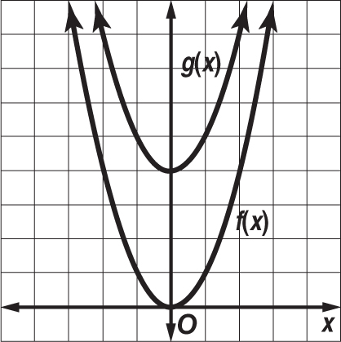

b. g(x) = ${(x + 3)}^{2}$
The value of h is –3, and –3 < 0. Thus, the graph of
g(x) = ${(x + 3)}^{2}$ is a translation of the graph of f(x) = $x^{2}$ to the left 3 units.
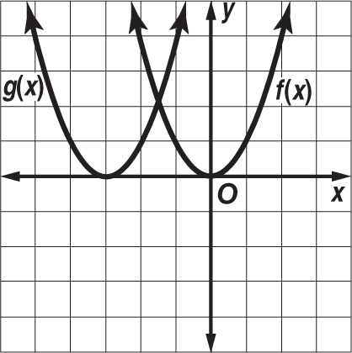

Exercises
Describe how the graph of each function is related to the graph of f(x) = x².
1. g(x) = $x^{2}$ + 1 2. g(x) = ${(x – 6)}^{2}$ 3. g(x) = ${(x + 1)}^{2}$

4. g(x) = 20 + $x^{2}$ 5. g(x) = ${(-2 + x)}^{2}$ 6. g(x) = – $\frac{1}{2}$ + $x^{2}$

7. g(x) = $x^{2}$ + $\frac{8}{9}$ 8. g(x) = $x^{2}$ – 0.3 9. g(x) = ${(x + 4)}^{2}$

9-3 Study Guide and Intervention (continued)
Transformations of Quadratic Functions

Dilations and Reflections A dilation is a transformation that makes the graph narrower or wider than the parent graph. A reflection flips a figure over the x- or y-axis.

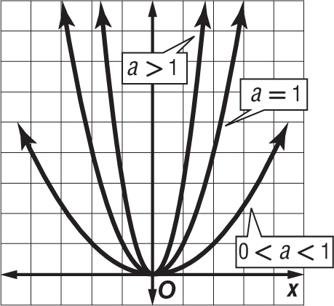
The graph of f(x) = ax² stretches or compresses the graph of f(x) = x².
If $\left|a\right|$ > 1, the graph of f(x) = x² is stretched vertically.
If 0 < $\left|a\right|$ < 1, the graph of f(x) = x² is compressed vertically.

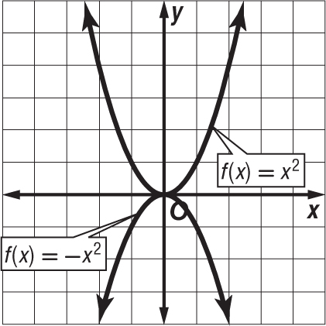

The graph of the function –f(x) flips the graph of f(x) = x² across the x-axis.
The graph of the function f(–x) flips the graph of f(x) = x² across the y-axis.

Example: Describe how the graph of each function is related to the graph of f(x) = $x^{2}$.

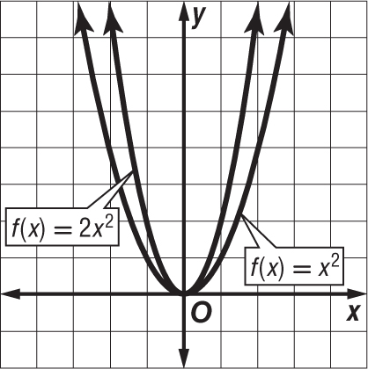
a. g(x) = 2$x^{2}$
The function can be written as f(x) = a$x^{2}$ where a = 2. Because $\left|a\right|$ > 1, the graph of y = 2$x^{2}$ is the graph of y = $x^{2}$ that is stretched vertically.
b. g(x) = – $\frac{1}{2}x^{2}$ – 3
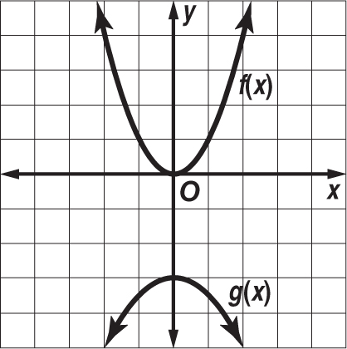
The negative sign causes a reflection across the x-axis. Then a dilation occurs in which a = $\frac{1}{2}$ and a translation in which k = –3. So the graph of g(x) = – $\frac{1}{2}x^{2}$ – 3 is reflected across the x-axis, dilated wider than the graph of f(x) = $x^{2}$, and translated down 3 units.

Exercises
Describe how the graph of each function is related to the graph of f(x) = $x^{2}$.
1. g(x) = –5$x^{2}$ 2. g(x) = – ${(x+1)}^{2}$ 3. g(x) = – $\frac{1}{4}x^{2}$ – 1

