Algebra 2 Practice Final 2017 SCORE ______________
(Chapters 5-6)

For Questions 1–2, simplify. Assume that no denominator equals 0.

1. $\sqrt{12}$ – $\sqrt{18}$ + 3$\sqrt{50}$ + $\sqrt{75}$

2. $\frac{2 + i}{1- 3i}$

3. Use synthetic division to find (2$x^{3}$ – 5$x^{2}$ + 7x – 1) ÷ (x – 1).

4. Write the expression $m^{\frac{7}{9}}$ in radical form.

5. Solve $\sqrt{3x + 6}$ + 4 ≤ 7.

6. Find p(–3) if p(x) = $x^{5}$ + 3$x^{2}$.

7. Solve $x^{4}$ + 200 = 102$x^{2}$.

8. Use synthetic substitution to find f(–3) for f(x) = 2$x^{3}$ – 6$x^{2}$ – 5x + 7.

9. One factor of f(x) = $x^{3}$ + $x^{2}$ – 22x – 40 is x + 4. Find the other factors.

10. List all of the possible rational zeros of f(x) = 3$x^{5}$ – 7$x^{3}$ + 2x – 15.

11. If f(x) = 3x and g(x) = 4x – 3, find f [g(5)] and g[ f(5)].

12. Find the inverse of f(x) = 7x – 2.

13. Simplify $\frac{4xy^{3}}{z^{2}}$ ÷ ${\left(\frac{8x^{2}y}{z^{3}}\right)}^{2}$.

14. Simplify $\frac{d}{ d^{2} - 9}$ + $\frac{5}{2d + 6}$.

15. Find the LCM of $m^{2}$ – 4m – 5 and $m^{2}$ + 8m + 7.

1. __________________________

2. __________________________

3. __________________________

4. __________________________

5. __________________________

6. __________________________

7. __________________________

8. __________________________

9. __________________________

10. _________________________

11. _________________________

12. _________________________

13. _________________________

14. _________________________

15. _________________________

Algebra 2 Practice Final 2017 (continued)

(Chapters 7-9)

16. Determine the equations of any vertical asymptotes and the value of x for any holes in the graph of f(x) = $\frac{x^{2}- 11 x + 18}{x – 2}$.

17. If y varies jointly as x and z and y = 100 when x = 10 and z = 5, find y
when x = 12 and z = 6.

18. Solve $\frac{8 }{t + 5}$ = $\frac{t – 3 }{t + 5}$ + $\frac{1}{3}$.

19. Sketch the graph of y = 1.5${(2)}^{x}$. Then state the function’s domain and range.

20. Determine whether y = 1.5 ${\left(\frac{1}{6}\right)}^{x}$ represents exponential growth or decay.

For Questions 21-25, solve each equation or inequality.
Round to four decimal places if necessary.

21. ${\left(\frac{1}{5}\right)}^{t - 2}$= 125 22. $\log_{4}{(x – 9)}$ = 2

23. $\log_{4}{z}$ + $\log_{4}{(z – 3)}$ = 1

24. ${3.9}^{m - 4}$ = 10.21 25. $e^{3x}$ ≥ 21

26. Use $\log_{5}{2}$ ≈ 0.4307 and $\log_{5}{3}$ ≈ 0.6826 to approximate the value of $\log_{5}{12}$.

27. Express $\log_{6}{19}$ in terms of common logarithms. Then approximate its value to four decimal places.

28. In a certain area, the sale price of new single-family homes has increased 4.1% per year since 1992. If a house was purchased in this area in 1992 for $75,000 and the growth continues, what will the sale price be in 2010? Use
y = a${(1+r)}^{t}$ and round to the nearest cent.

16. _________________________

17. _________________________

18. _________________________

19. _________________________
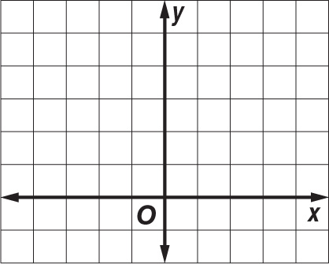

20. _________________________

21. _________________________

22. _________________________

23. _________________________

24. _________________________

25. _________________________

26. _________________________

27. _________________________

28. _________________________

