Basic Algebra Practice Final 2017

1. Which of the following figures show a 90° counter -clockwise rotation of the figure shown below?

A.

B.

C.

D.

2. If point H(–6, 2) is translated 4 units down and 3 units left, what are the coordinates of the translated image?

F. H'(–2, 5)

G. H'(–3, 6)

H. H'(–9, –2)

I. H'(–9, 6)

3. The dilation of $\overline{CD}$ is shown below. What is the scale factor of the dilation?
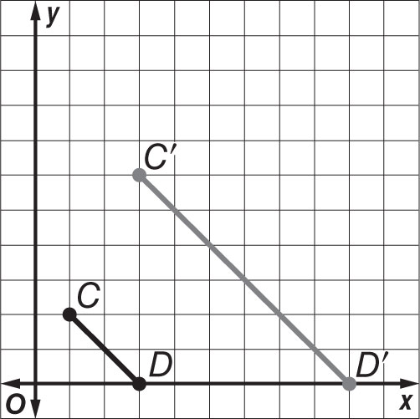

A. $\frac{1}{3}$

B. $\frac{1}{2}$

C. 2

D. 3

4. Point N(6, –5) is reflected across the y-axis. What are the coordinates of the image?

F. N'(–6, –5)

G. N'(–5, 6)

H. N'(5, –6)

I. N'(6, 5)

Basic Algebra Practice Final 2017 (continued)

5. Suppose triangle RST shown on the coordinate grid is reflected across the y-axis. Which ordered pair does not represent a vertex of the reflected triangle?

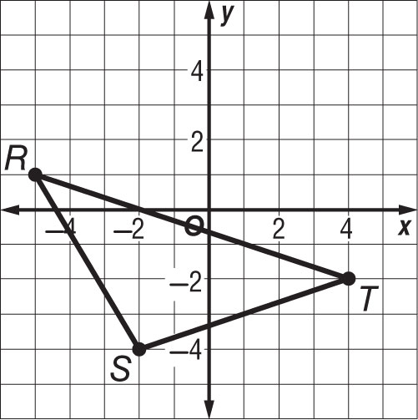

F. (5, 1)

G. (–4, –2)

H. (2, –4)

I. (–2, 4)

6. Which rotation best describes the transformation shown below?
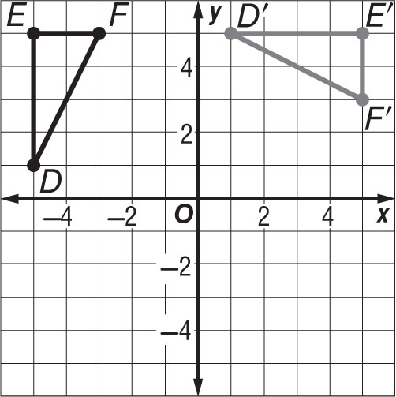

F. 90° counterclockwise rotation

G. 270° clockwise rotation

H. 180° rotation

I. 90° clockwise rotation

7. Which transformation does result in an image similar to the original figure, but different size?

A. translation

B. dilation

C. reflection

D. rotation

8. Mary enlarged a 4- by 6-inch photo to a 10- by 15-inch photo. What is the scale factor of the dilation?

A. 2

B. 2.5

C. 6

D. 9

9. The area of a figure is 64 square centimeters. Suppose the sides of the figure are doubled. What will be the new area of the similar figure?

A. 16 square centimeters

B. 32 square centimeters

C. 128 square centimeters

D. 256 square centimeters

Basic Algebra Final 2017

10. Triangle MNO is similar to triangle WXY. Which of the following statements is not necessarily true?
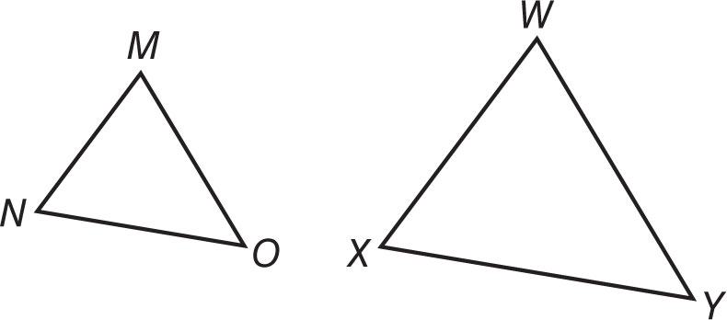

F. ∠Y = $∠$O

G. $\frac{MO}{MN}=\frac{WX}{WY}$

H. ∠N = ∠X

I. $\frac{MN}{NO}=\frac{WX}{XY}$

11. What is the volume of a sphere with a radius of 9 inches?

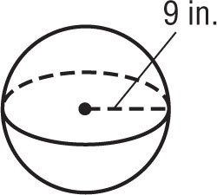

A. 1016π in³

B. 972π in³

C. 486π in³

D. 324π in³

12. SHORT ANSWER The two-way table shows the number of boys and girls in the school band and choir. Is there a greater percentage of boys in the school band or in the choir? Explain.
 | Band | Choir
Boys | 14 | 5
Girls | 12 | 9

13. A soup can has a diameter of 8 centimeters and a height of 15 centimeters. About how much soup does the can hold? Use 3.14 for π. Round to the nearest tenth.

F. 376.8 ${cm}^{3}$

G. 753.6 ${cm}^{3}$

H. 1028.7 ${cm}^{3}$

I. 3014.4 ${cm}^{3}$

14. SHORT ANSWER The table shows the number of goals scored by the Cougars so far this soccer season.
Game | 1 | 2 | 3 | 4 | 5
Goals Scored | 1 | 5 | 3 | 4 | 2

What is the mean absolute deviation?

15. Suppose the dimensions of a rectangular prism are enlarged by a factor of 2. By what scale factor will the volume of the prism be scaled?
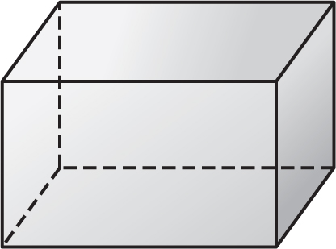

A. $\frac{1}{2}$

B. 8

C. 6

D. 2

Basic Algebra Final 2017 (continued)

16. What type of relationship is shown in the scatter plot below?

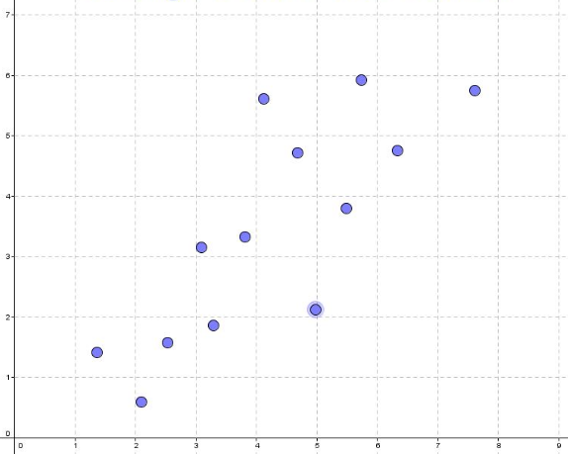

A. positive

B. negative

C. skewed

D. no relationship

17. About how much water can the paper drinking cup shown below hold? Use 3.14 for π. Round to the nearest tenth.
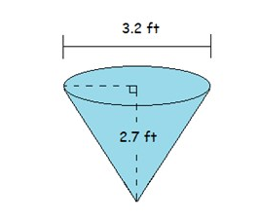

F. 17.2 cubic inches

G. 7.2 cubic inches

H. 5.7 cubic inches

I. 4.5 cubic inches

18. SHORT ANSWER Determine if the two figures below are congruent by using transformations. Explain your reasoning.

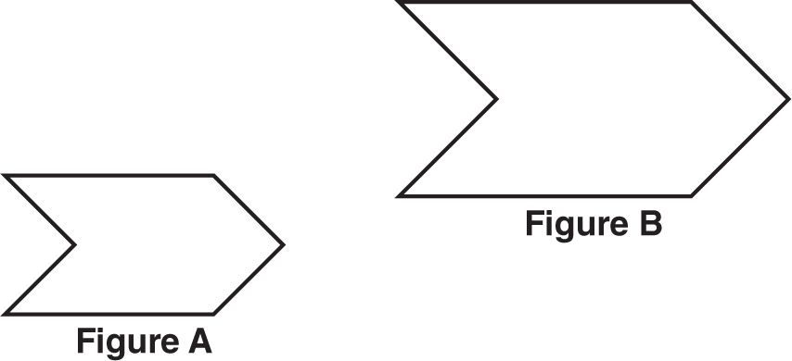

19. Which two points form a line that has a slope of $-1$?

A. (3, 6) and (–1, –4)

B. (4, 2) and (7, –1)

C. (–4, 7) and (–9, 5)

D. (3, –7) and (8, 4)

20. What is the constant rate of change of the function represented in the table below?

x | y
–4 | –9
–2 | –3
0 | 3
2 | 9

F. 2

G. 3

H. 5

I. 6

21. Which transformations could have been used to map the first figure to the second?
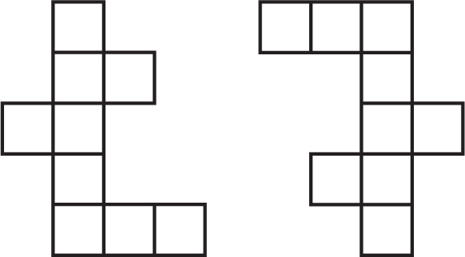

A. dilation, translation

B. dilation, reflection

C. reflection, rotation

D. translation, rotation

Basic Algebra Final 2017 (continued)

22. Katie is 5 feet tall. She casts a 8-foot long shadow at the same time that a tree casts an 24-foot long shadow.
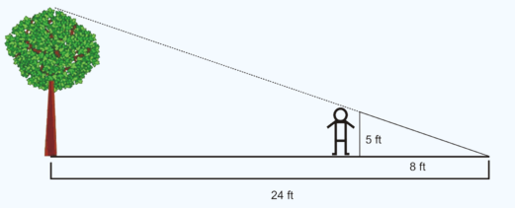

What is the height of the flagpole?

F. 10 ft

G. 25 ft

H. 15 ft

I. 30 ft

23. What is the approximate surface area of a cylinder with a height of 12 meters and a base radius of
2 meters? Use 3.14 for π. Round to the nearest tenth if necessary.

A. 242.1 $m^{2}$

B. 175.8 $m^{2}$

C. 150.7 $m^{2}$

D. 124.5 $m^{2}$

24. SHORT ANSWER The area of a square patio is
169 square feet. What is the perimeter of the patio?
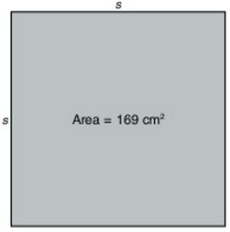

25. A cone has a height of 24 inches, a slant height of
25 inches, and a diameter of 14 inches. What is the surface area of the cone?

A. 1,176π in²

B. 392π in²

C. 224π in²

D. 178π in²

26. SHORT ANSWER What is the relationship between the slope of the line and the side lengths of the triangles?
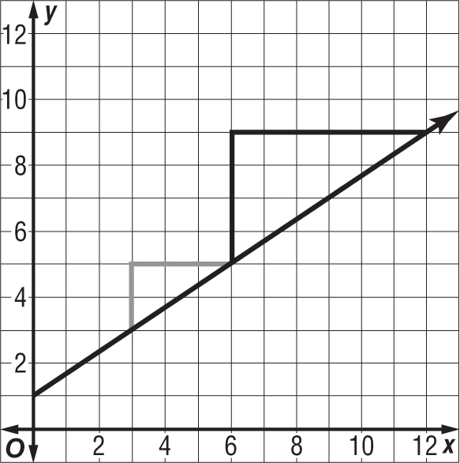

27. What is the slope of the line that passes through points R(2, 0) and T(–4, –3)?

A. 2

B. $\frac{1}{2}$

C. − $\frac{1}{2}$

D. − 2

Basic Algebra Final 2017 (continued)

28. What type of transformation is represented by the figures below?
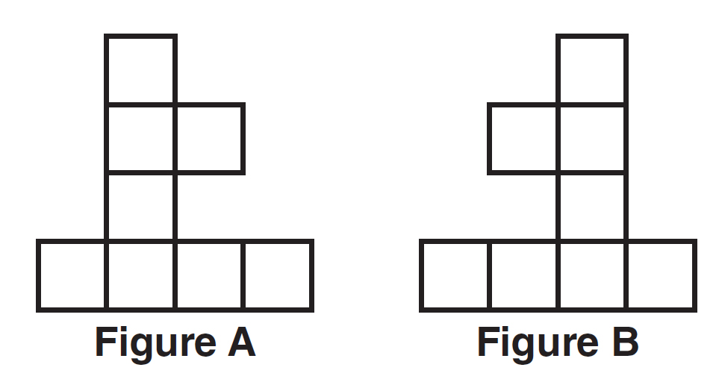

A. dilation
B. reflection
C. rotation
D. translation

29. Which series of transformations can be used to prove that triangle HIJ is similar to triangle H’I’J’?
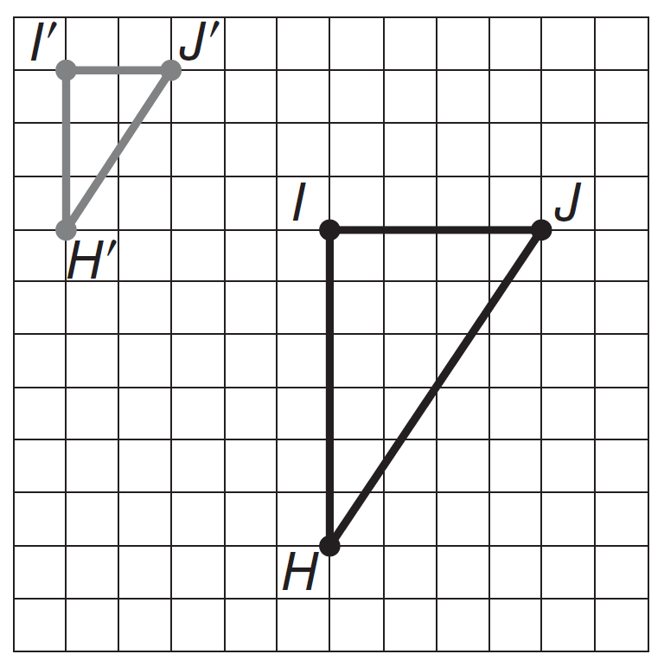

A. reflection, dilation
B. 90° rotation, dilation
C. translation, dilation
D. 180° rotation, dilation

30. Which of the following statements about a line of best fit is not true?
F. Most of the data points are close to the line.
G. About half of the points are above the line.
H. All of the data points have to be on the line.
I. The line can be used to make conjectures.

31. By what factor would you need to multiply the dimensions of a polygon in order for the resulting image to have a perimeter that is equal to 4 the original perimeter?
A. $\frac{1}{4}$ C. 2
B. $\frac{1}{2}$ D. 4

32. What is the scale factor of the dilated figure shown below, going from LMN to RST?
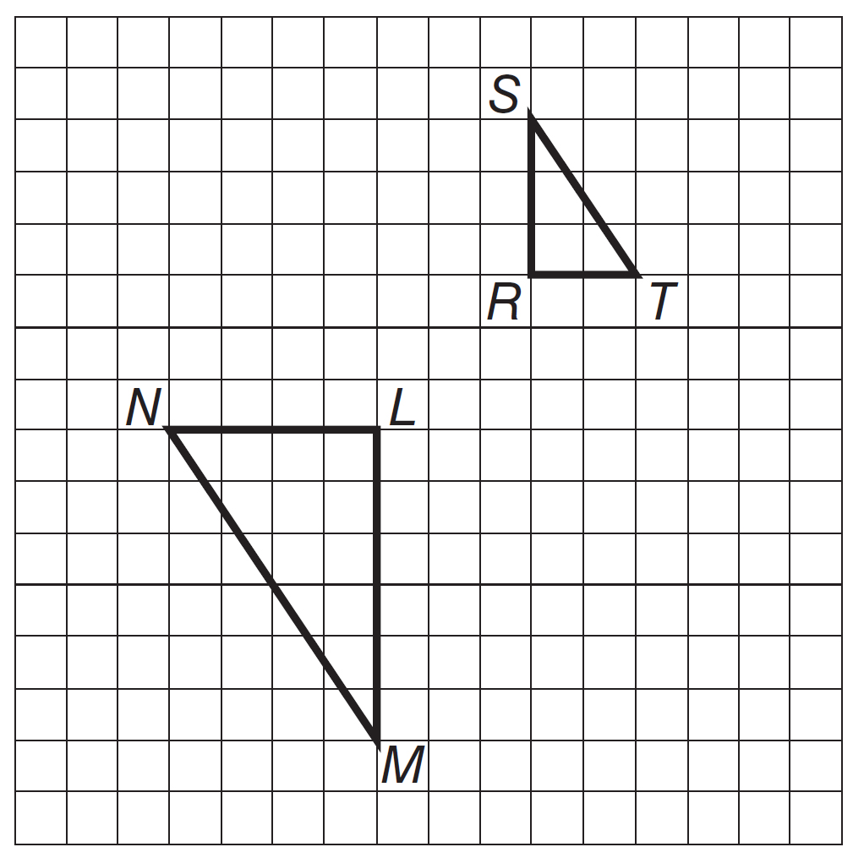

A. 0.25 C. 2
B. 0.5 D. 4

33. Point A(–7, –3) is reflected across the x-axis. What are the coordinates of the image?
F. A'(3, –7) H. A'(–3, –7)
G. A'(–7, 3) I. A'(7, –3)

