Lesson 1 Skills Practice

Volume of Rectangular Prisms

Find the volume of each prism.

1. 2. 3.
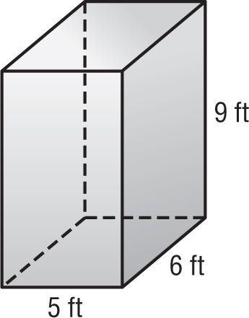
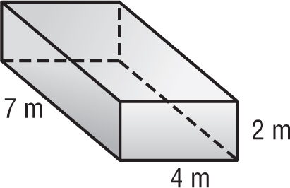
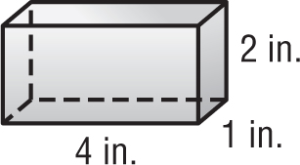

4. 5. 6.
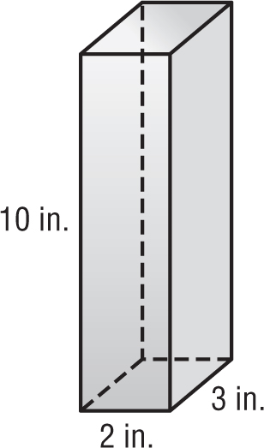
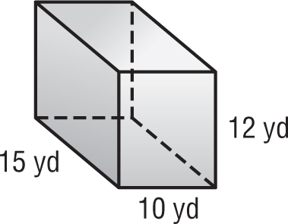
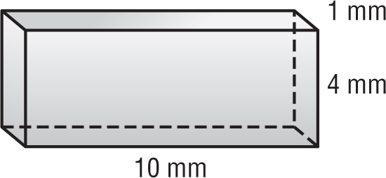

7. 8. 9.
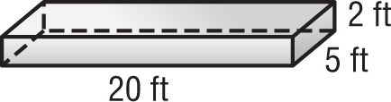
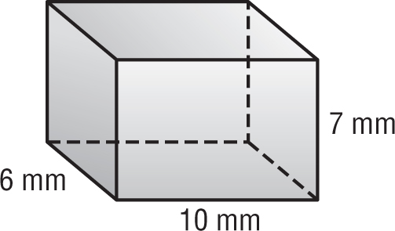
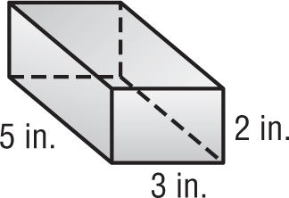

Find the missing dimension of each prism.

10. 11. 12.
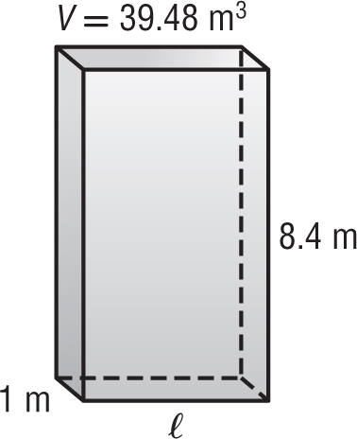
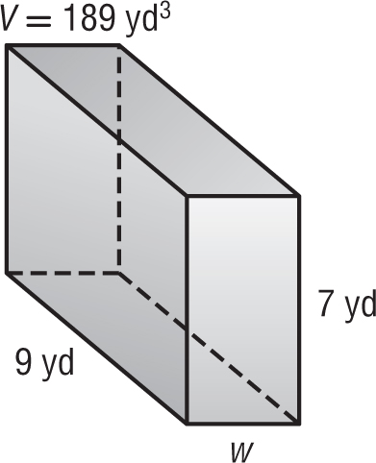
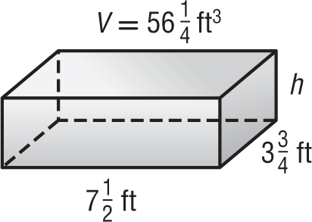

13. Find the volume of a rectangular prism with length 9 meters, width 4 meters, and height 5 meters.

14. What is the volume of a rectangular prism with length 6 yards, width 3 yards, and a height of 2 yards?

Lesson 1 Homework Practice

Volume of Rectangular Prisms

Find the volume of each prism.

1. 2. 3.
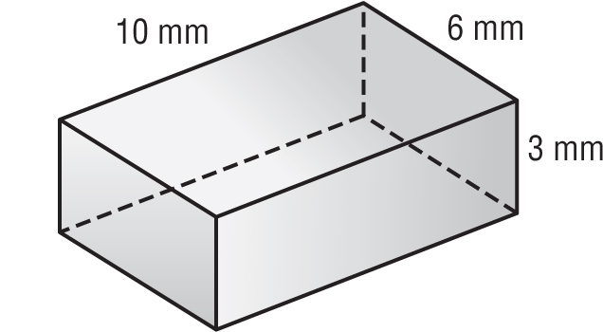
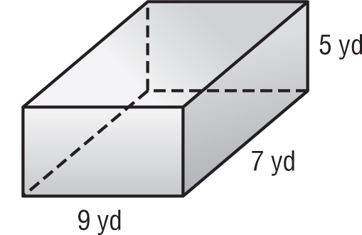
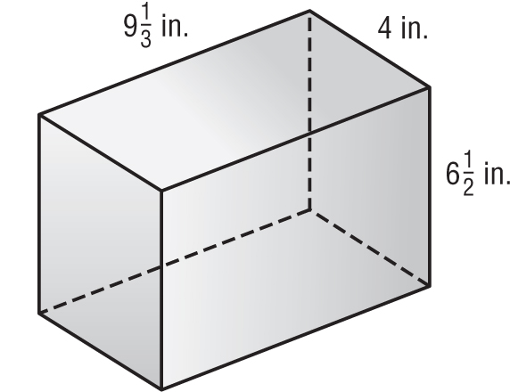

4. 5. 6.
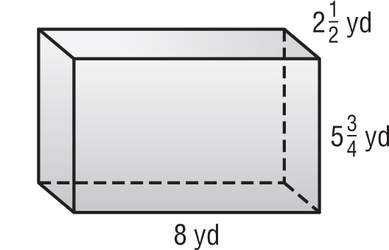
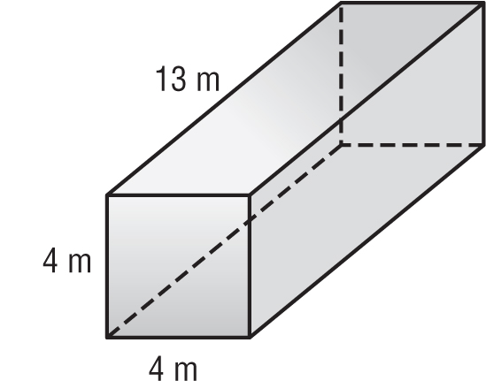
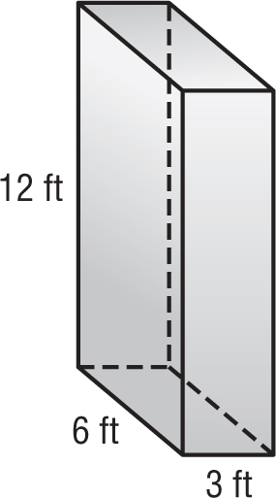

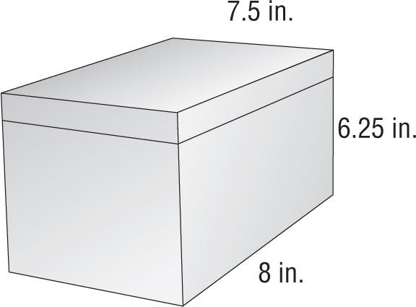
7. MUSIC Find the volume of the CD box shown at the right.

8. TOYS Geneva’s younger brother has a toy box that is 3.6 feet long, 2.4 feet wide, and 1.5 feet high. What is the volume of the toy box?

9. What is the volume of a rectangular prism with a length of 11 meters, width of 26 meters, and height of 38 meters?

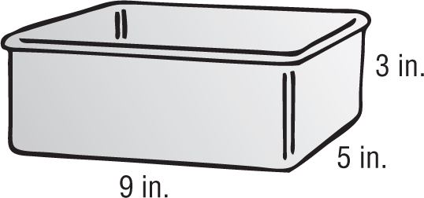
10. BAKING The bread loaf pan shown is filled to a height of 2 inches with banana bread batter. How much more batter could the pan hold before it overflowed?

Lesson 1 Problem-Solving Practice

Volume of Rectangular Prisms

1. OLYMPICS Olympic gold medal winner Michael Phelps competes in a pool with required dimensions 25 meters by 50 meters by 2 meters. What is the volume of the Olympic-sized pool? Explain how you found your answer. | 2. DUMP TRUCKS Raphael drives a standard-sized dump truck. The dimensions of the bed of the truck are length 15 feet, width 8 feet, and height 6 feet. What is the volume of the bed of the dump truck?
3. GIFTS William has some antique bottles. He is going to fill the bottles with bath soap and give them away as gifts. Use the figure to find the volume up to the fill line of a bottle.  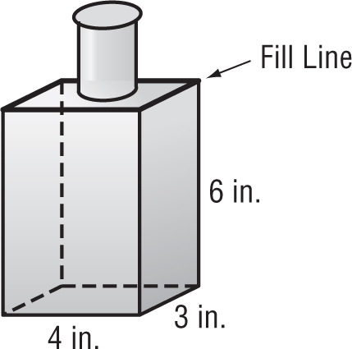 | 4. JEWELRY Janine keeps her jewelry in a jewelry box like the figure below. Find the volume of Janine’s jewelry box.  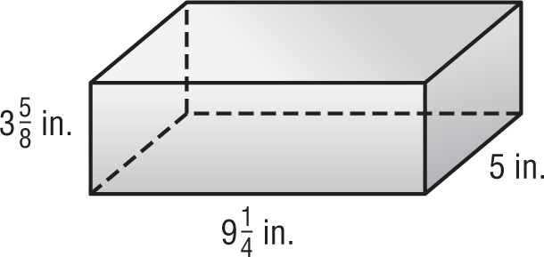
5. RECYCLING The town of Riverview provides a rectangular recycling bin for newspapers to each household. If the volume is 3,840 cubic inches, what is the height of the recycling bin?  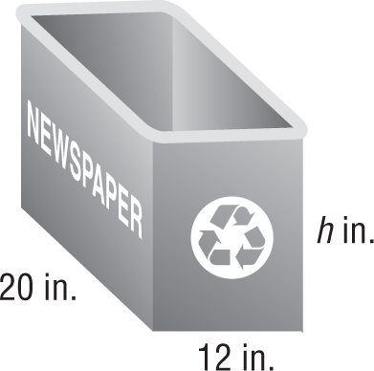 | 6. CANDLE MAKING Kyle fills the candle mold with liquid candle wax. If the candle has a volume of 99 cubic inches, what is the width of the mold?  