Lesson 2 Skills Practice

Volume of Triangular Prisms

Find the volume of each prism. Round to the nearest tenth if necessary.

1. 2. 3.
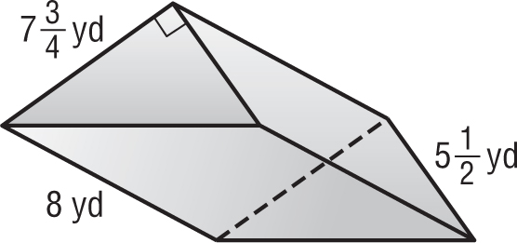
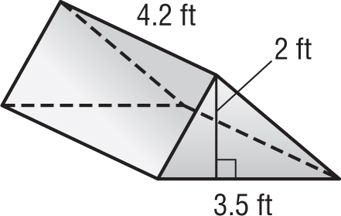
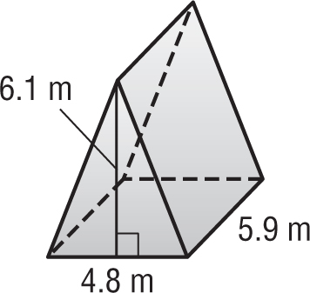

4. 5. 6.
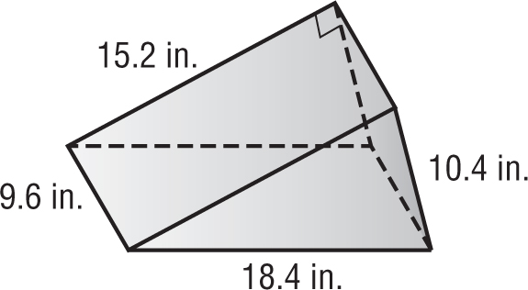
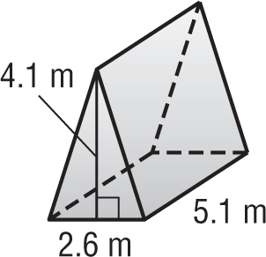
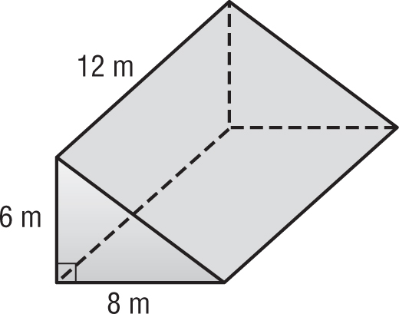

7. 8. 9.
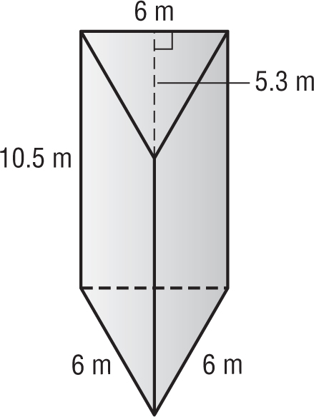
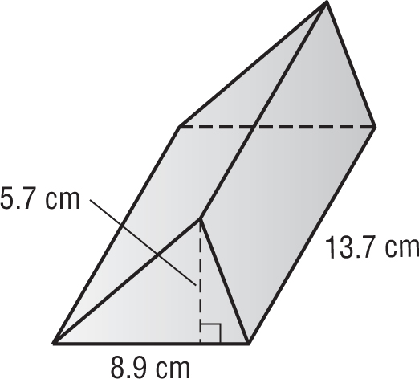
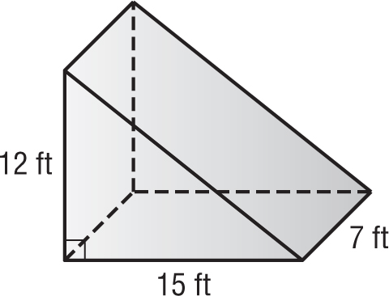

Lesson 2 Homework Practice

Volume of Triangular Prisms

Find the volume of each prism. Round to the nearest tenth if necessary.

1. 2. 3 .
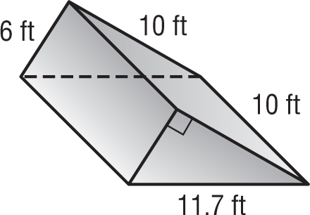
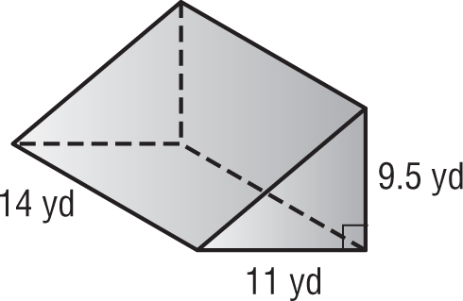
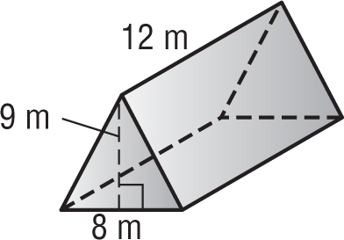

4. 5. 6.
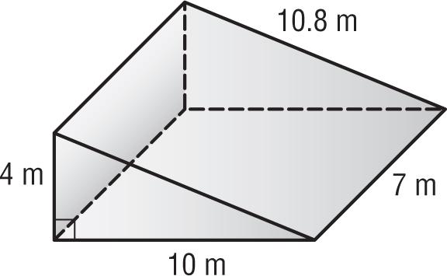
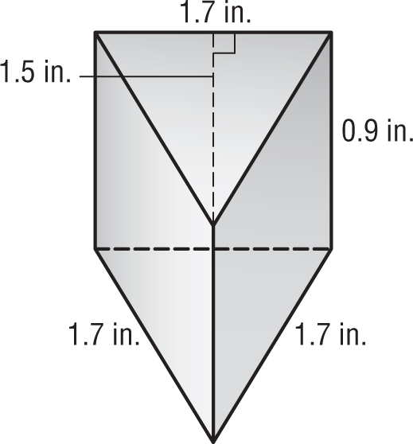
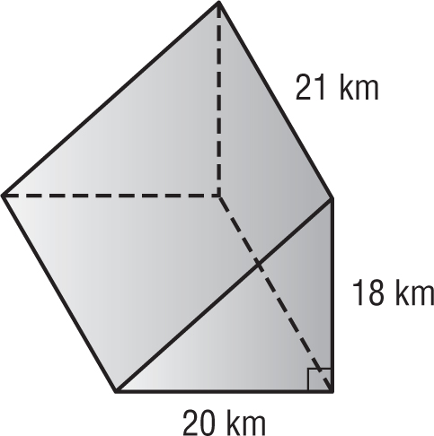

7. 8. 9.
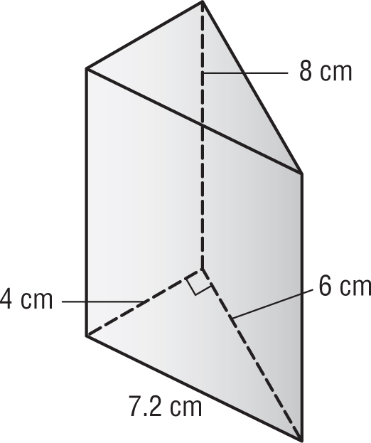
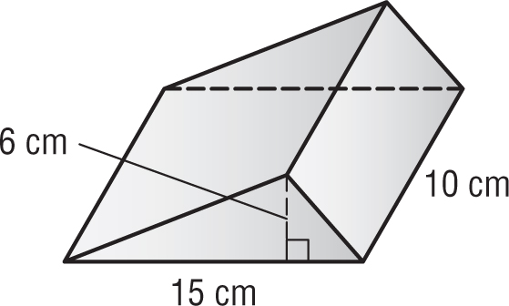
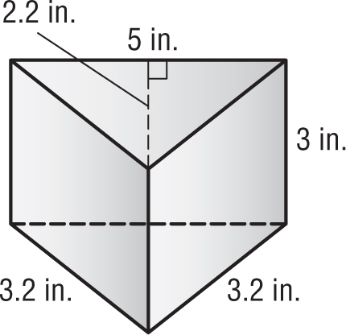

10. WEDGE The base of a triangular door wedge has an area of 55 square centimeters. The height of the wedge is 5 centimeters. Find the volume of the door wedge.

11. GAME A wooden peg game in the shape of a triangular prism is 2 inches tall. The triangle has a base of 12 inches and a height of 9 inches. Find the volume of the game.

Lesson 2 Problem-Solving Practice

Volume of Triangular Prisms

1. TOY BLOCKS A set of wooden blocks includes a triangular prism like the one shown below. Find the volume of the block.  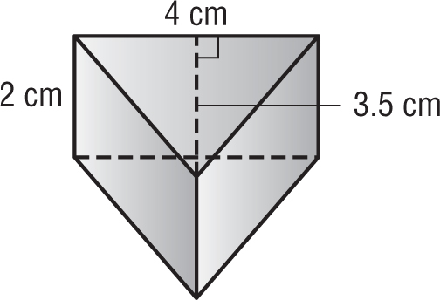 | 2. RAMP The base of a bicycle ramp has an area of 4 square feet. The ramp is a triangular prism. If the ramp has a height of $2\frac{1}{2}$feet, what is the volume of the ramp?
3. CLAY A potter crafts a triangular prism out of clay. The height of the clay prism is 9 centimeters. Each triangle has a base of 12 centimeters and a height of 4 centimeters. What is the volume of the clay piece? | 4. CABIN An A-frame cabin is built in the shape of a triangular prism, as shown. The front wall of the cabin has a length of 9 meters and a height of 7 meters. The cabin is 13 meters deep. Find the volume of the cabin.  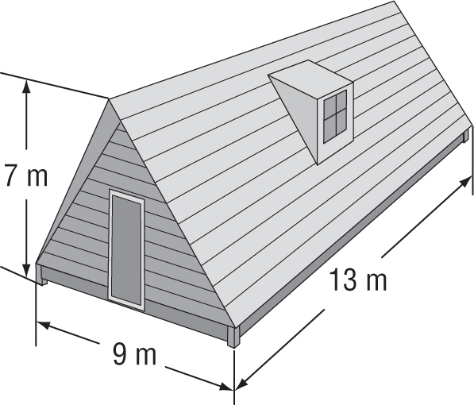
5. PAPERWEIGHT A novelty paperweight has a triangular base with an area of 15 square centimeters. If the height of the paperweight is 1.5 centimeters, what is the volume of the paperweight? | 6. SANDBOX Mr. Riojas is building his children a sandbox that is shaped like a triangular prism. He uses 7-foot-long wooden beams for each side of the base. He measures the height of the triangular base to be 6.1 feet. If he makes the sandbox 1 foot tall, how much sand will he need to fill it? Round to the nearest cubic foot.

