Lesson 4 Skills Practice

Surface Area of Triangular Prisms

Find the surface area of each triangular prism. Round to the nearest tenth if necessary.

1. 2.
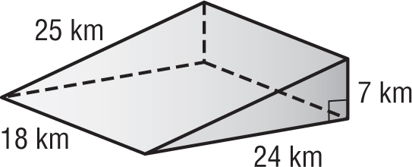
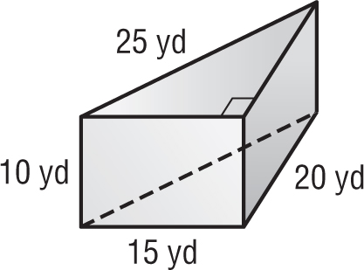

3. 4.
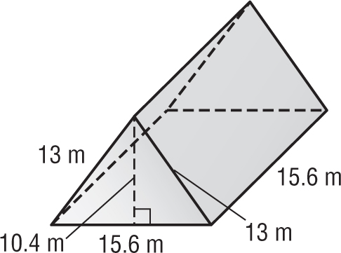
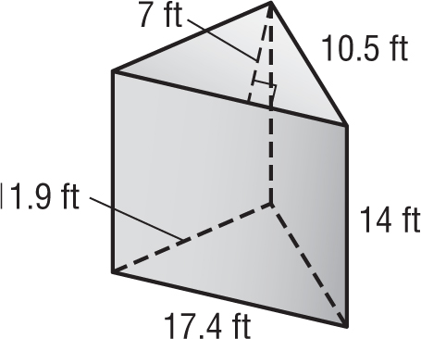

5. 6.
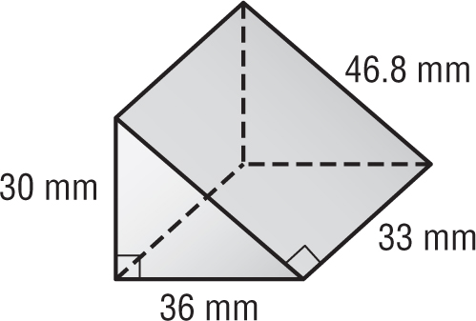
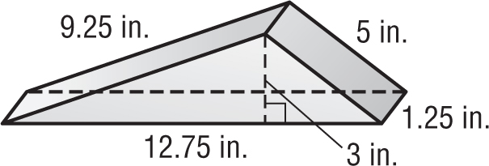

7. A box of snack crackers is in the shape of a triangular prism. What is the surface area of the box?
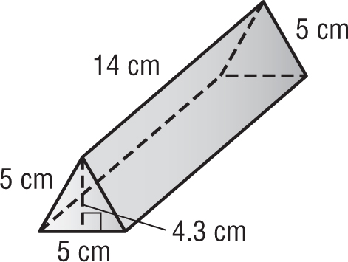

Lesson 4 Homework Practice

Surface Area of Triangular Prisms

Find the surface area of each triangular prism. Round to the nearest tenth if necessary.

1. 2.
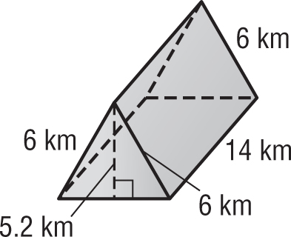
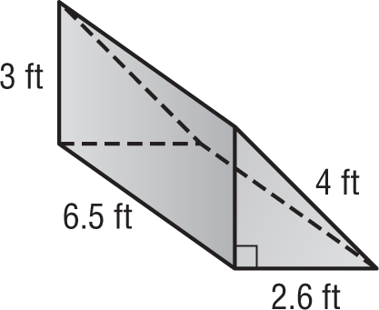

3. 4.
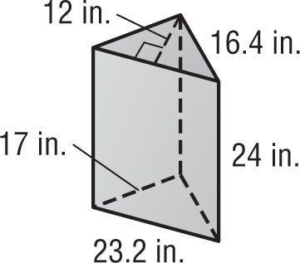
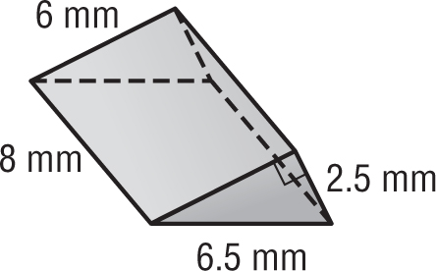

5. One foam block on the playground at Teeny Tots Preschool is a triangular prism. About how much material is used to cover the block?
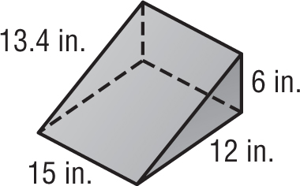

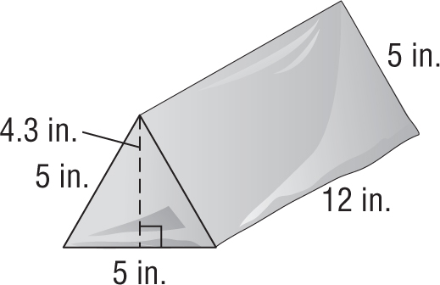

6. The box for the jungle animal figurines is in the shape of a triangular prism. What is the surface area of the box?

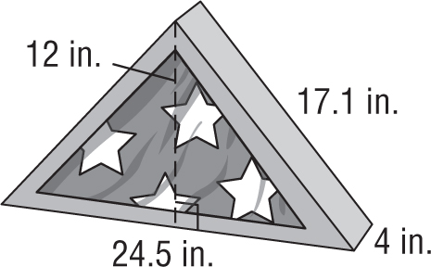

7. The storage box for a flag is in the shape of a triangular prism. What is the surface area of the box?

Lesson 4 Problem-Solving Practice

Surface Area of Triangular Prisms

1. PIZZA Find the amount of cardboard needed to make a box for a single slice of pizza. The box is in the shape of a triangular prism as shown.  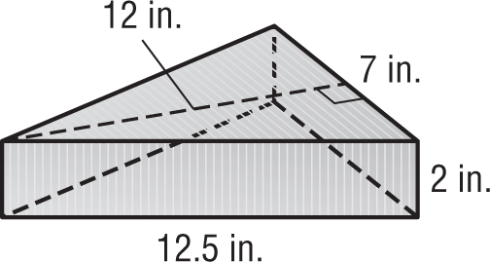 | 2. RAMPS Sturdy Steel Construction is building a steel ramp in the shape of a triangular prism. The dimensions are shown below. What is the surface area of the ramp?  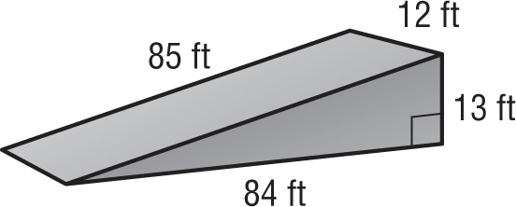
3. CAMPING The Canvas Camping Company makes canvas tents like the one shown. How much material is needed to make the tent?  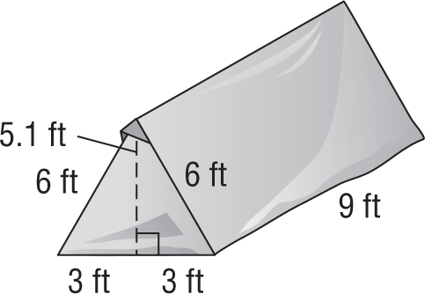 | 4. DISPLAY CASES Find the surface area of Anna’s glass doll display case. The case is in the shape of a triangular prism as shown.  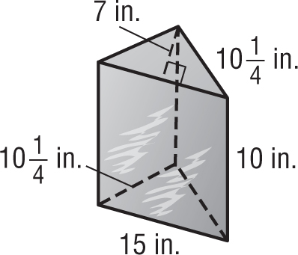
5. GIFTS Mariska purchased a gift box in the shape of a triangular prism. The dimensions are shown below. What is the surface area of the gift box?  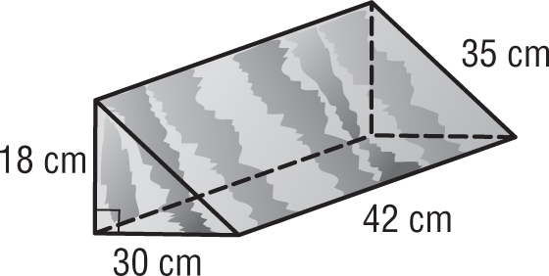 | 6. PACKAGING Pascal’s Peanut Company packages dry-roasted peanuts in a box in the shape of a triangular prism. The dimensions are shown below. What is the surface area of the box?  