Lesson 5 Skills Practice

Surface Area of Pyramids

Find the surface area of each pyramid. Round to the nearest tenth if necessary.

1. 2. 3.
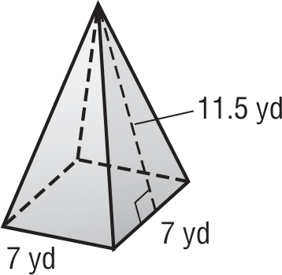
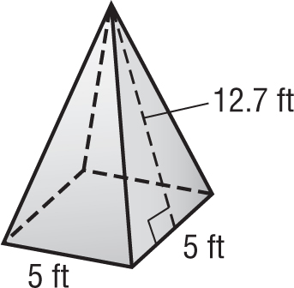
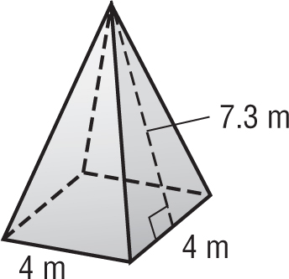

4. 5. 6.
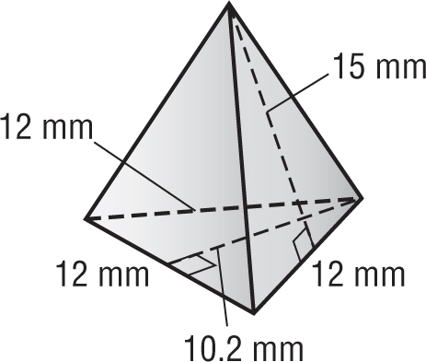
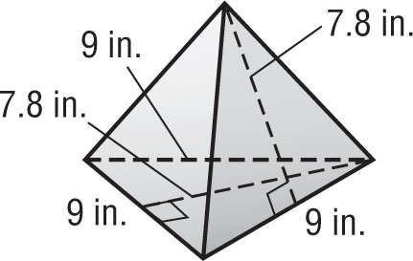

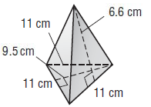

7. 8. 9.
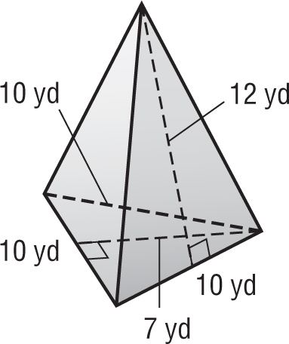
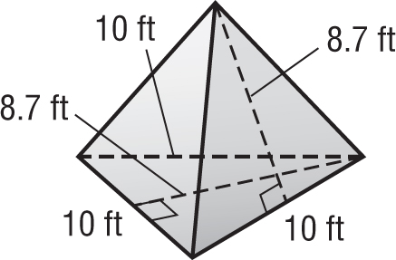
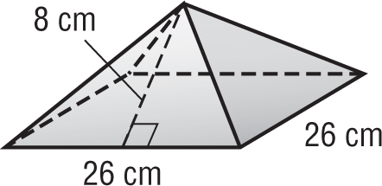

10. OFFICE DÉCOR Mr.Statsko has a paper weight on his desk in the shape of a square pyramid. The dimensions of the pyramid are shown. What is the surface area of the paper weight?
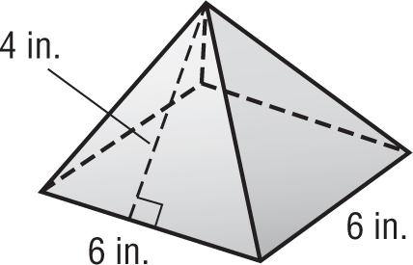

Lesson 5 Homework Practice

Surface Area of Pyramids

Find the surface area of each pyramid.

1. 2. 3.
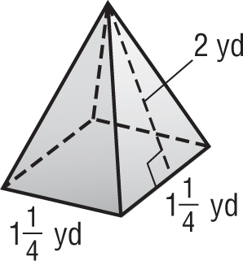
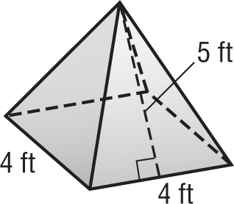
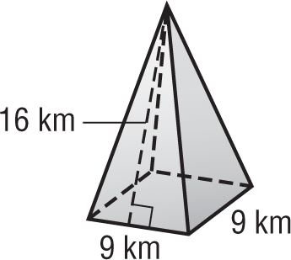

4. 5. 6.
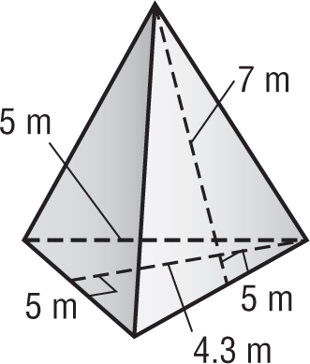
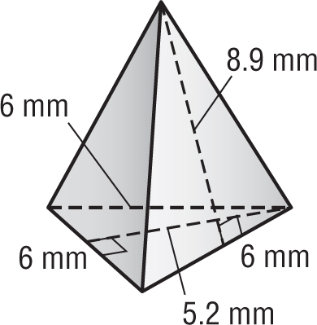
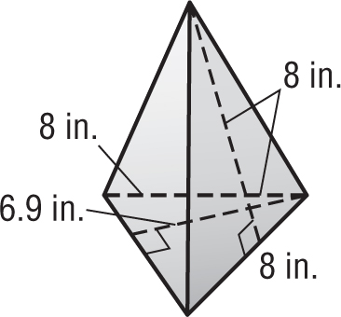

7. GOLF Marshall purchased a pyramid-shaped golf ball display case with the dimensions shown. What is the surface area of the case? Round to the nearest hundredth.

8. PUZZLES Potter’s Puzzles sells a wooden pyramid puzzle. The base is a square with side lengths of 6 inches. The slant height is 10 inches. What is the surface area of the puzzle?
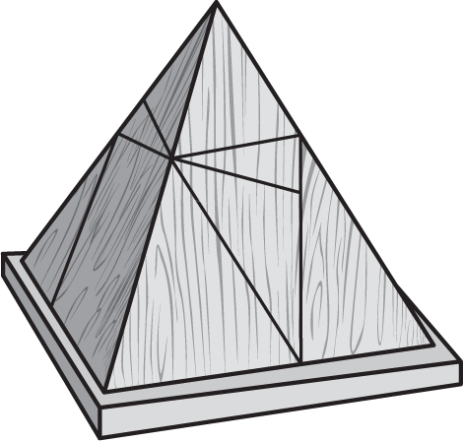

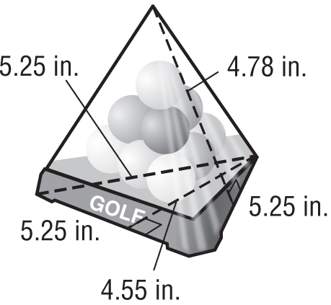

9. ART Mariah is painting the surface of a sculpture in the shape of a square pyramid. The base has side lengths of 32 centimeters. The slant height is 25 centimeters. What is the surface area of the sculpture?

Lesson 5 Problem-Solving Practice

Surface Area of Pyramids

1. FOUNTAINS A sculpture in the water fountain at Casey Creek Park is in the shape of a square pyramid. The base of the sculpture is 2 feet long and 2 feet wide. The slant height is 5 feet. What is the surface area of the sculpture? | 2. TENTS Tent Potential, Inc. makes a tent in the shape of a square pyramid. The base of the tent is 3.4 meters long and 3.4 meters wide. The slant height of the tent is 2 meters. What is the surface area of the tent?  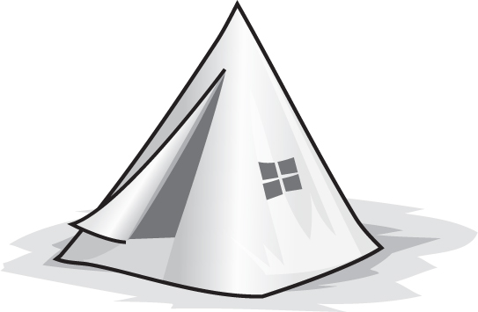
3. STAGE SET Rock It Out builds stage sets for rock concerts in the shape of a square pyramid. One set has a base that is 12 feet long and 12 feet wide. The slant height of the set is 13.4 feet. What is the surface area of the stage set? | 4. TOYS Toddler Builders makes a toy block in the shape of a triangular pyramid. The base of the block is an equilateral triangle with dimensions of 6 inches. The height of the base is 5.2 inches and the slant height of the block is 8 inches. What is the surface area of the pyramid block?  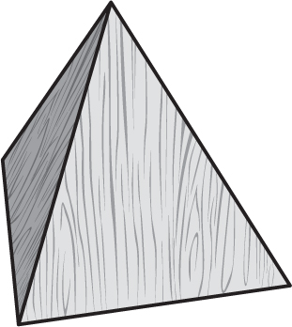
5. PARACHUTES Marcus’s science class is testing a toy parachute in the shape of a square pyramid. The opening at the base is 20 centimeters long and 20 centimeters wide. The slant height of the parachute is 14.1 centimeters. What is the surface area of the parachute? (Hint: The surface area of the parachute does not include the base.)  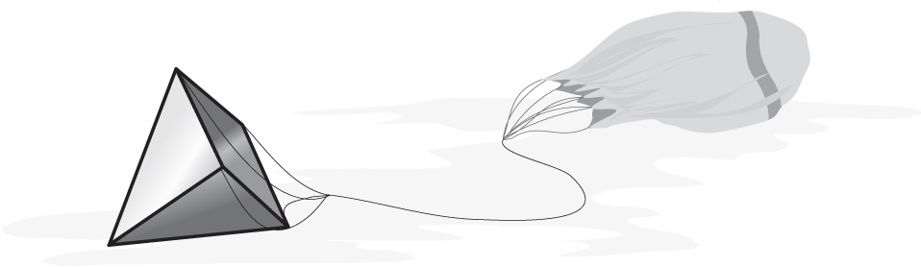 | 6. ARCHITECTURE Glass skylights on the roof of Jezebelle’s apartment building are in the shape of a square pyramid. The base of each skylight is 8 feet long and 8 feet wide. The slant height is 6.4 feet. How much glass is used to make each skylight? (Hint: The skylight does not have a glass base.)  