Chapter 10 Practice Test SCORE ______________

Write the letter for the correct answer in the blank at the right of each question.

1. How does the graph of y = $\sqrt{x}$ + 2 compare to the parent graph?

2. Which expression has a domain of {x | x ≥ –1}?
F y = $\sqrt{x+1}$ G y = $\sqrt{x-1}$ H y = $\sqrt{x}$ + 1 J y = $\sqrt{x}$ – 1

For Questions 3–7, simplify each expression.

3. $\sqrt{90}$

4. $\frac{3}{5 - \sqrt{2}}$

5. 6$\sqrt{5}$ – 2$\sqrt{5}$

6. 3$\sqrt{12}$ + $\sqrt{27}$ – 2$\sqrt{20}$

7. $\sqrt{2}$ ($\sqrt{6}$ + 3$\sqrt{2}$ )

8. Solve $\sqrt{2x-5}$ = 3.

9. Solve $\sqrt{2x+8}$ = x.

10. Find the length of the hypotenuse of a right triangle if a = 3 and b = 4.

11. Determine which side measures form a Pythagorean triple.
A 4, 5, 6 B 3, 4, 5 C 5, 11, 12 D 4, 8, 12

1. _______________

2. _______________

3. _______________

4. _______________

5. _______________

6. _______________

7. _______________

8. _______________

9. _______________

10. _______________

11. _______________

Chapter 10 Practice Test (continued)

12. Determine which set of measures can be the lengths of the sides of a right triangle.
A 2, 3, 5 B 4, 6, 7 C 10, 12, 13 D 1, $\sqrt{3}$ , 2

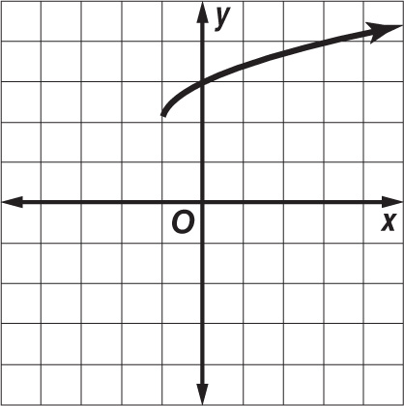
13. What is the equation of the graph?
F y = $\sqrt{x+2}$ + 1 H y = $\sqrt{x+1}$ + 2
G y = $\sqrt{x-2}$ + 1 J y = $\sqrt{x-1}$ + 2

14. Simplify 2$\sqrt{x}$ ⋅ 5$\sqrt{x}$ ⋅ 3$\sqrt{x}$ .

15. What is the length of a diagonal of a rectangle with a length of 8 meters and a width
of 6 meters?

16. Determine which side measures form a right triangle.
A 10, 24, 28 B 13, 17, 21 C $\sqrt{3}$, $\sqrt{4}$, $\sqrt{5}$ D 5, 12, 13

17 . SAILING A 12-foot cable attached to the top of the mast of a sailboat is fastened to a point on the deck 4 feet from the base of the mast. What is the height of the mast?

Bonus: Find out when you take the test

12. _______________

13. _______________

14. _______________

15. _______________

16. _______________

17. _______________

B. _______________

