Chapter 11 Review A SCORE _________

Write the correct letter for the correct answer in the blank at the right of each question.

For Exercises 1 and 2 use the following set of data:
2, 3, 3, 4, 5, 7, 8, 8, 8, 10, 10, and 12.

1. What are the third and first quartiles of the data?
A. 12, 2 B. 8, 4.5 C. 10, 3 D. 9, 3.5

2. What is the interquartile range of the data?
F. 10 H. 7
G. 7.5 I. 5.5

3. The table shows the number of movies owned by a group of surveyed people.
Number of Movies
11 | 31 | 17 | 22 | 18 | 25
25 | 10 | 15 | 12 | 30 | 12
29 | 25 | 21 | 32 | 30 | 25

What is the median of movies owned?
A. 21.5 C. 23.5
B. 22 D. 25

4. What is the mean absolute deviation of the data: 10, 17, 20, 12, and 16?
Round to the nearest whole number.
F. 15 H. 3
G. 5 I. 2

For Exercises 5-7, use the dot plot below.
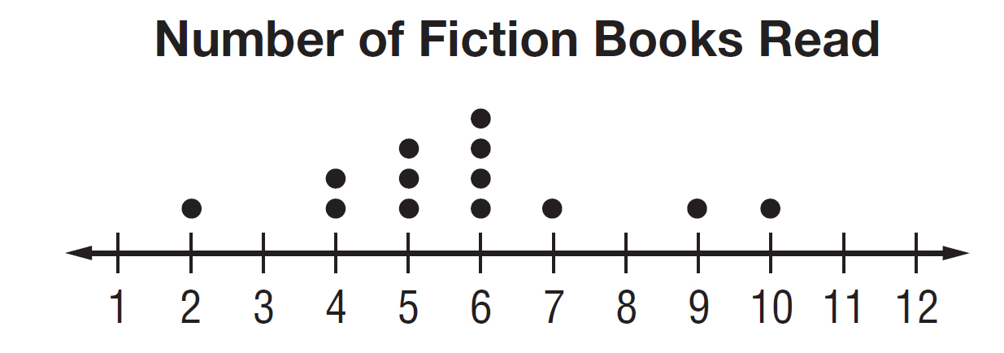

5. What is the mean of the data? Round to the nearest tenth.
A. 5.7 B. 5.2 C. 5 D. 4.5

6. What is the median of the data?
F. 10 G. 9 H. 6 I. 3

7. What is the mode of the data?
A. 3 B. 6 C. 8 D. 10

1.___________

2. ___________

3. ___________

4. ___________

5. ___________

6. ___________

7. ___________

Chapter 11 Review A (continued) SCORE _________

For Exercises 8-10, which measure of center best represents each set of data?

8. number of television sets in the home: 4, 4, 2, 4, 4, 1, 3, 4, 2, 4
F. mean G. median H. mode I. range

9. goals scored during hockey season: 7, 6, 9, 3, 12, 7, 2, 10, 7, 8
A. mean B. median C. mode D. range

10. prices of earrings: $4, $30, $10, $12, $10, $20, $12, $10
F. mean G. median H. mode I. range

11. Find the mean absolute deviation of the data set 8, 8, 10, 15, 9, 20, 12, and 10. Round to the nearest hundredth if necessary.
A. 0.52 C. 3.5
B. 3.13 D. 11.5

12. The results of a survey about the number of contacts stored in cell phones is shown in the table
Number of Contacts
100 | 31 | 45 | 85 | 98 | 29
75 | 62 | 78 | 50 | 72 | 84
50 | 40 | 83 | 88 | 44 | 94

What is the first quartile of the data?
F. 40 H. 45
G. 44.5 I. 85

13. Jamie mowed 7 lawns. He earned $10, $15, $12, $15, $8, and $15 for six lawns. How much did he earn the seventh time if the mean of the data is $12?
A. $9 C. $12
B. $10 D. $15

8.___________

9. ___________

10. ___________

11. ___________

12. ___________

13. ___________

