Chapter 11 Review B SCORE _________

Write the letter for the correct answer in the blank at the right of each question.

For Exercises 1 and 2, use the following set of data: 5, 7, 7, 6, 4, 8, 17, 5, 7, 5, 6, and 5.

1. Find the third and first quartiles of the data.
A. 7, 5 B. 6.5, 6 C. 17, 4 D. 8, 6

2. Find the interquartile range of the data.
F. 2 H. 12
G. 5 I. 17

3. The table shows the prices of sneakers in a store.
Price of Sneakers ($)
40 | 37 | 25 | 35 | 29 | 43
34 | 26 | 39 | 43 | 51 | 47
35 | 27 | 45 | 28 | 50 | 43

What is the median price for the sneakers?
A. $25 C. $38
B. $29 D. $43

4. What is the mean absolute deviation of the data: 10, 20, 15, 17, and 13?
F. 15 H. 3
G. 10 I. 2.8

For Exercises 5-7, use the dot plot below.
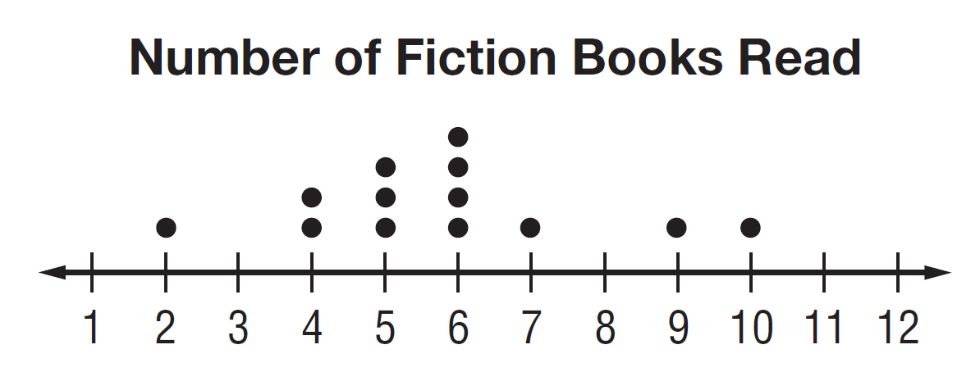

5. What is the mean of the data? Round to the nearest tenth.
A. 13 B. 7.5 C. 5.8 D. 2.9

6. What is the mode of the data?
F. 10 G. 6 H. 5 I. 2

7. What is the median of the data?
A. 4 B. 5 C. 6 D. 7

1._____________

2. _____________

3. _____________

4. _____________

5. _____________

6. _____________

7. _____________

Chapter 11 Review B (continued) SCORE _________

For Exercises 8-10, which measure of center best represents each set of data?

8. runs scored during the baseball season: 8, 6, 9, 3, 12, 4, 2, 10, 7, 8
F. mean H. mode
G. median I. range

9. prices of earrings: $6, $12, $15, $12, $12, $20, $12, $13
A. mean C. mode
B. median D. range

10. number of telephones in the home: 3, 3, 5, 4, 3, 8, 3, 4, 3, 6, 2
F. mean H. mode
G. median I. range

11. Find the mean absolute deviation of the data set 8, 10, 15, 8, 12, 13, 12 and 14. Round to the nearest hundredth if necessary.
A. 1.7 C. 2.13
B. 2.05 D. 4.25

12. The table shows the results of a survey about the number of contacts stored in cell phone.
Number of Contacts
100 | 31 | 45 | 85 | 98 | 29
75 | 62 | 78 | 50 | 72 | 84
50 | 40 | 83 | 88 | 44 | 94

What is the third quartile of the data?
F. 67 H. 84
G. 83 I. 85

13. Laura mowed 8 lawns. She earned $12, $10, $15, $15, $15, $10, and $9 for seven lawns. How much did she earn the eighth time if the mean of the data is $12?
A. $9 C. $12
B. $10 D. $15

8.______________

9. ______________

10. ______________

11. ______________

12. ______________

13. ______________

