Lesson 1 Skills Practice

Scatter Plots

Explain whether the scatter plot of the data for each of the following shows a positive, negative, or no association. Interpret the scatter plot.

1. 2.
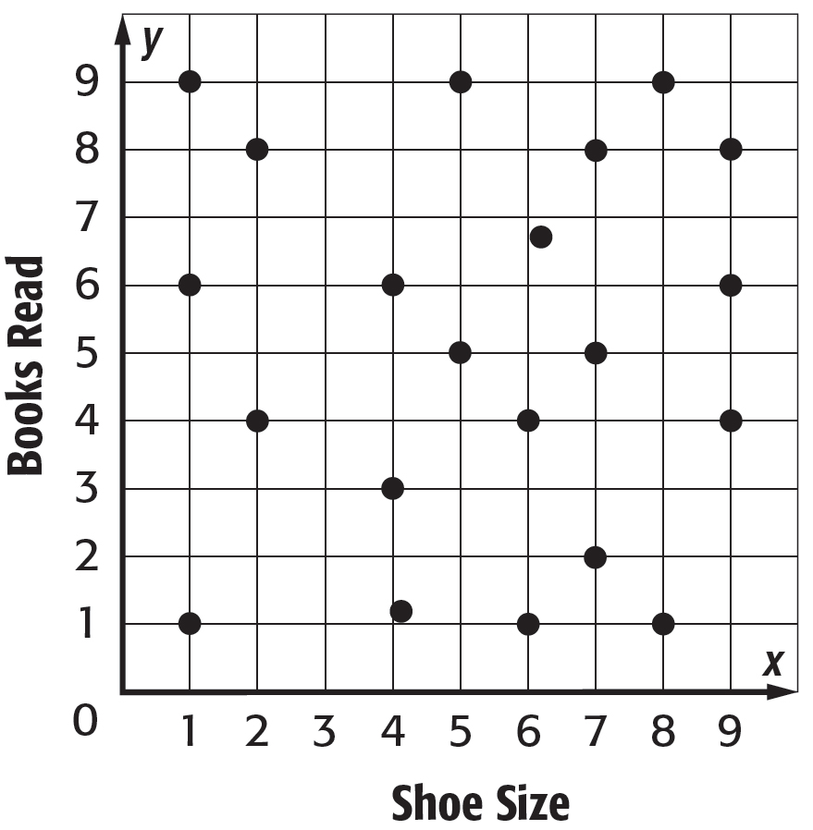
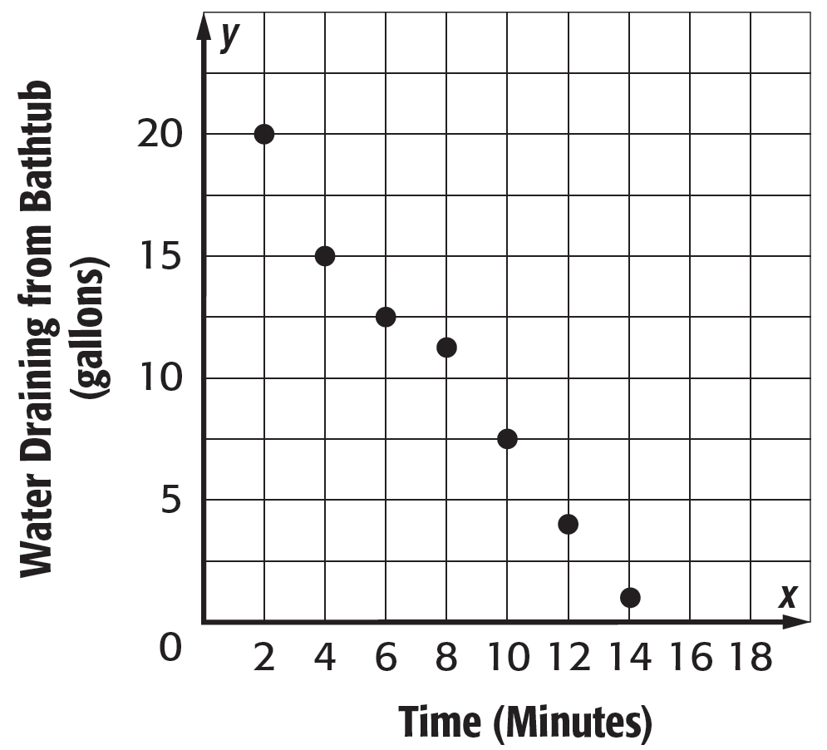

3. 4.
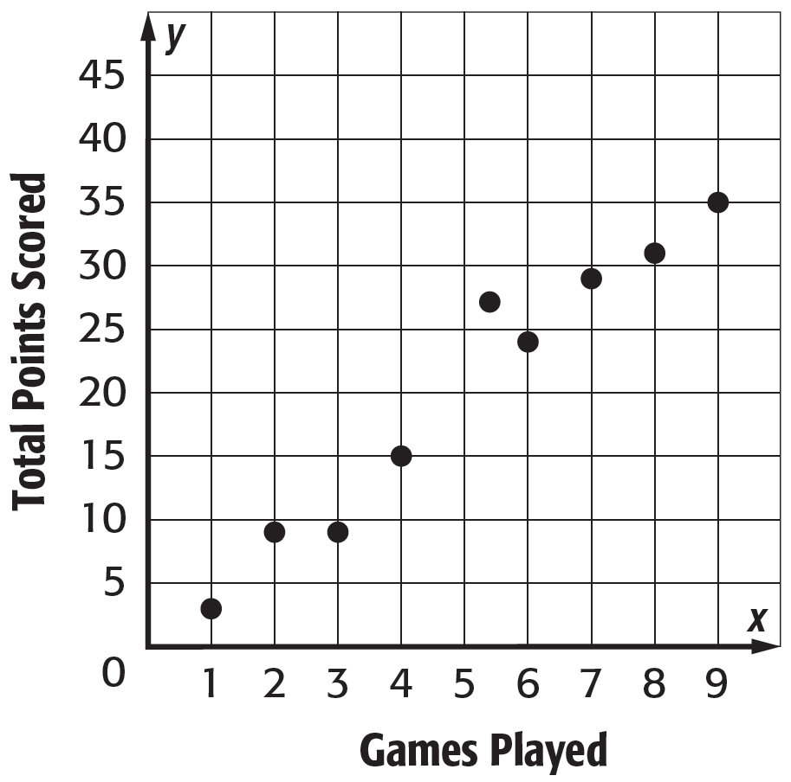
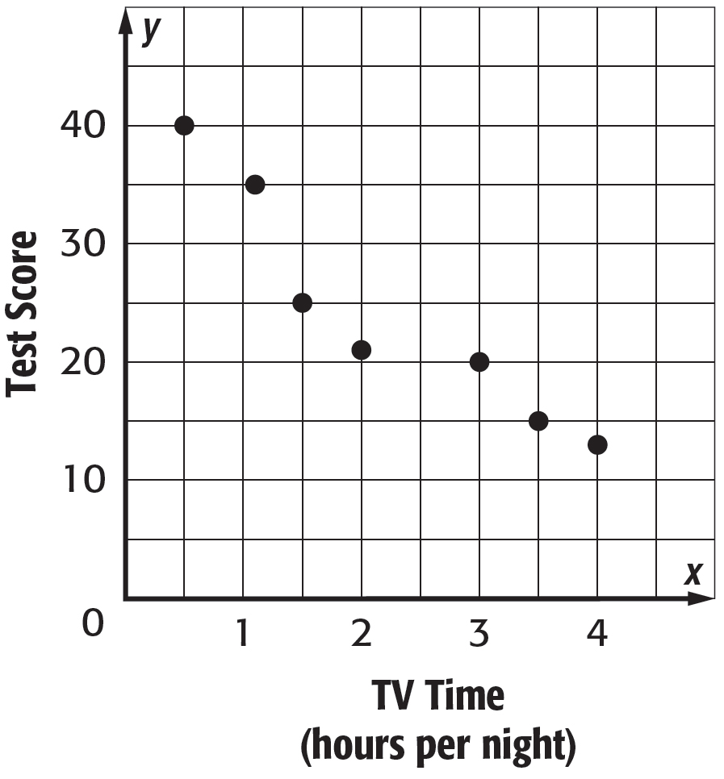

5. E-MAIL Construct a scatter plot of the number of E-mails Vincent received over the past six days. Interpret the scatter plot.
Day | 1 | 2 | 3 | 4 | 5 | 6
E-mails | 16 | 21 | 3 | 11 | 19 | 5

Lesson 1 Homework Practice

Scatter Plots

Interpret each scatter plot.

1. 2. 3.
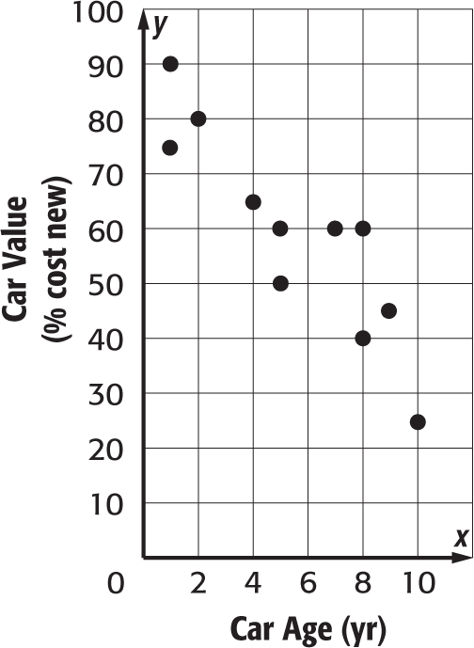
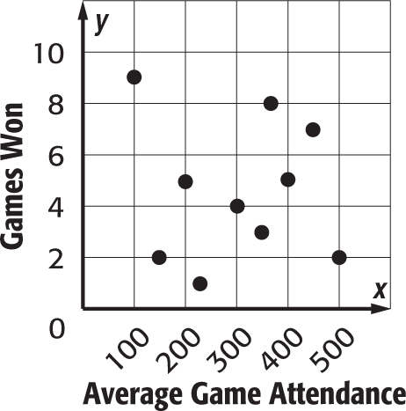
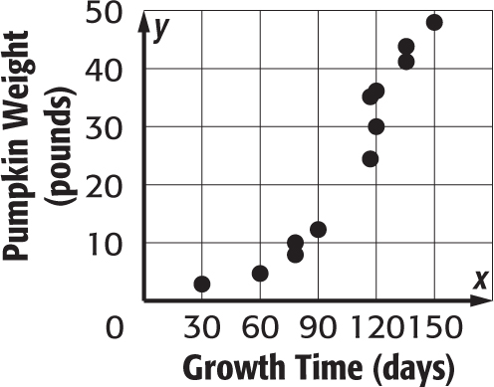

4. RIVER Construct a scatter plot of the river’s width and the water’s speed.
River Width (m) | 15 | 18 | 20 | 28 | 30 | 32 | 38 | 40 | 42 | 45
Water Speed (km/h) | 12.6 | 10.7 | 11.2 | 9.7 | 8.1 | 8.7 | 6.9 | 5.4 | 3.9 | 4.1

5. DONATIONS Construct a scatter plot of the number of cars donated to a local charity over the past five years since 2007.
Years Since 2007 | 1 | 2 | 3 | 4 | 5
Number of Cars | 14 | 21 | 30 | 28 | 35

Lesson 1 Problem-Solving Practice

Scatter Plots

WAGES For Exercises 1 and 2, use the BRICKS For Exercises 3 and 4, use the
table below. table below.
Time  (minutes) | Bricks Remaining
0 | 600
10 | 565
20 | 530
30 | 495
40 | 460
50 | 425

Years Since 2002 | Average  Hourly Wage
1 | $12.25
2 | $12.75
3 | $13.50
4 | $14.00
5 | $14.75
6 | $15.25

1. Construct a scatter plot of the data. | 3. Construct a scatter plot of the data.
2.  a. Does the scatter plot show a positive, negative, or no association? Explain.  b. If an association exists, make a conjecture about the hourly wages in 2009. | 4.  a. Does the scatter plot show a positive, negative, or no association? Explain.  b. If an association exists, make a conjecture about the number of bricks remaining to be loaded after 1 hour and 10 minutes has passed.

Lesson 1 Extra Practice
Scatter Plots
1. The number of pieces in a jigsaw puzzle and the number of minutes required for a person to complete it is shown below.
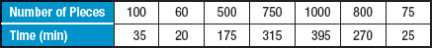
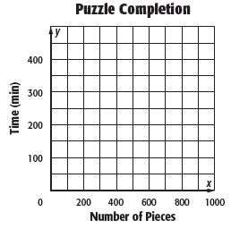
a. Make a scatter plot of the data.
b. Interpret the scatter plot of the data based on the shape of the distribution. Sample answer: the scatter plot shows a positive linear association. There are no clusters or outliers.

c. Suppose Dave purchases a puzzle having 650 pieces. Predict the length of time it will take him to complete the puzzle. Sample answer: 260 min

2. The table shows the number of gold medals won by the United States Olympic team at the Summer Olympics from 1968 through 2008.
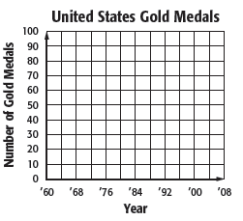
a. Make a scatter plot of the data.
b. Interpret the scatter plot of the data based on the shape of the distribution. Sample answer: The scatter plot shows a linear association. There are no clusters and one outlier.

c. Is it possible to predict the number of gold medals won in 2016? Explain. Sample answer: There is not a positive or negative relationship, but the number of medals is around 40 each year. You could reasonable predict that the number of gold medals in 2016 would be around 40.

