Lesson 2 Skills Practice

Lines of Best Fit

1. BOATING Rehan’s yacht holds 70 passengers. Each hour he stops at the marina to let some passengers off and on. The table shows how many passengers are on board during each hour of boating.
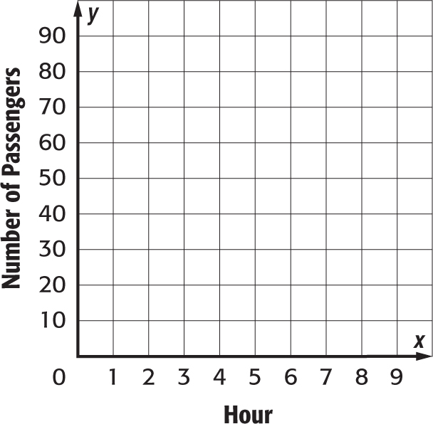
Hour | 1 | 2 | 3 | 4 | 5
Passengers | 30 | 40 | 32 | 40 | 55

a. Construct a scatter plot of the data. Then draw and assess a line that seems to best represent the data.

b. Use the line of best fit to make a conjecture about the number of passengers on the boat during hour 8.

2. RESALE VALUE The table shows the resale value of six SUVs plotted against the age of the vehicle.
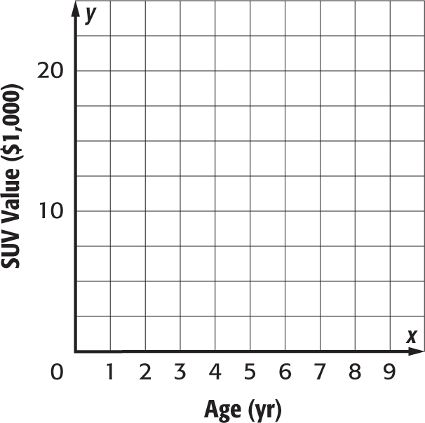

Age (yr) | 1 | 2 | 3 | 4 | 5 | 6
Value ($1,000) | 24 | 22 | 19 | 17 | 16 | 13

a. Construct a scatter plot of the data. Then draw and assess a line that seems to best represent the data.

b. Use the line of best fit to estimate the resale value of a 7-year-old SUV.

3. BIRD WATCHING Sage belongs to a bird-watching club. Every two days, she goes out and counts the number of Black-hooded Parakeets she sees. The scatter plot shows the number of parakeets she saw in the past 12 days.
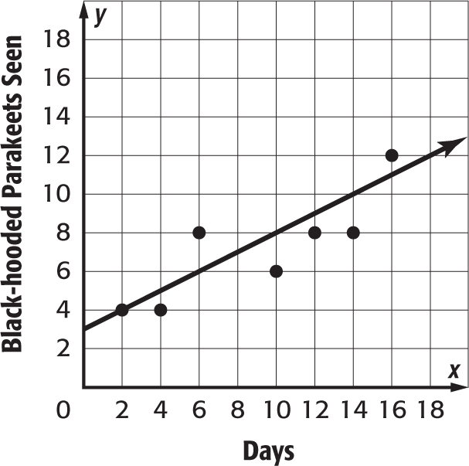
a. Write an equation in slope-intercept form for the line that is drawn.

b. Use the equation to make a conjecture about the number of parakeets she saw on the eighteenth day.

Lesson 2 Homework Practice

Lines of Best Fit

1. BALLOONS Salina is having a surprise party for her friend Ernie. The table shows how many balloons she has been able to blow up by the end of each 10-minute segment.
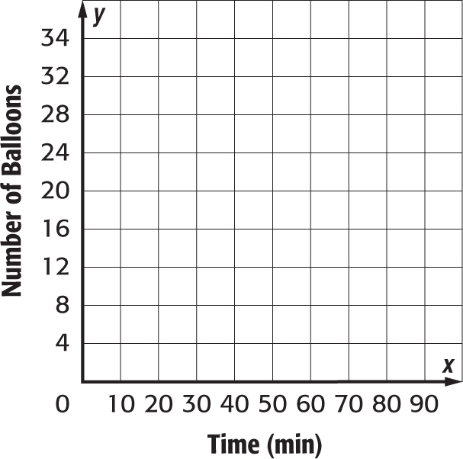
Time (min) | 10 | 20 | 30 | 40 | 50
Balloons | 3 | 12 | 15 | 16 | 21

a. Construct a scatter plot of the data. Then draw and assess a line that seems to best represent the data.

b. Use the line of best fit to make a conjecture about the number of balloons she will have blown up at the end of 70 minutes.

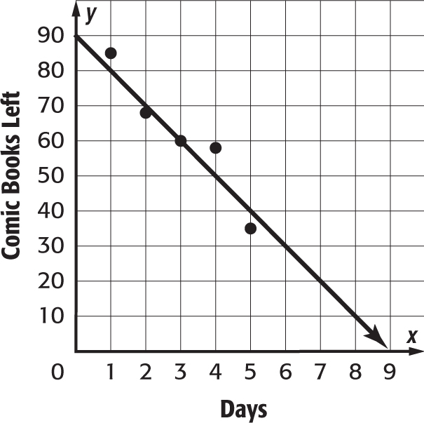
2. COMIC BOOKS Sidney is selling his comic book collection on the Internet. The scatter plot shows how many comic books he has left at the end of each day.

a. Write an equation in slope-intercept form for the line that is drawn.

b. Use the equation to make a conjecture about the number of comic books he will have at the end of the seventh day.

3. ICE RINK Maury has an ice rink in his back yard. The scatter plot shows the thickness of the ice relative to the temperature.
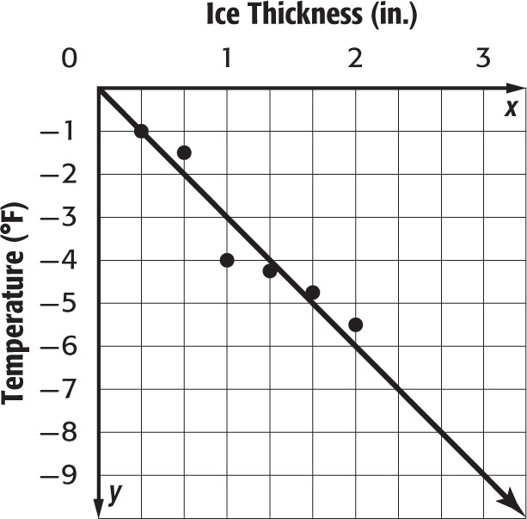

a. Write an equation in slope-intercept form for the line that is drawn.

b. Use the equation to make a conjecture about the $\frac{1}{3}$ inches.

Lesson 2 Problem-Solving Practice

Lines of Best Fit

FALL Haley has a leaf-raking company to help offset school costs. The table shows how many bags of leaves Haley was able to fill each hour. Use the information in the table to answer Exercises 1 and 2.
Hour | 1 | 2 | 3 | 4 | 5
Bags Filled | 3 | 4 | 5 | 8 | 14

1. Construct a scatter plot of the data. Then draw and assess a line that represents the data.  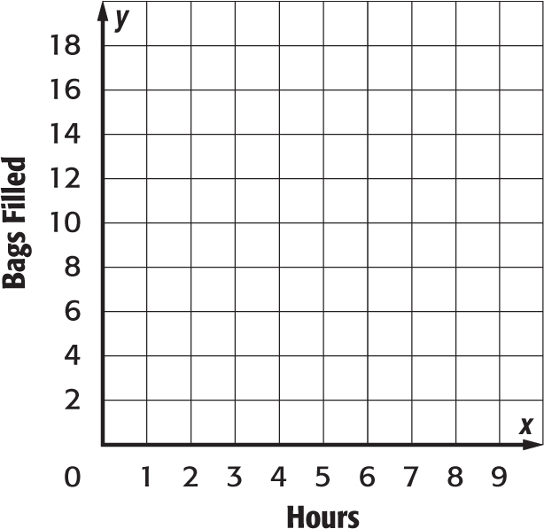 | 2. Use the line of best fit to make a conjecture as to how many bags of leaves Haley will have filled at the end of 7 hours of raking.

BABY POOL Cleo’s baby pool has a leak. The scatter plot shows the amount of water left in the pool at the end of each 5-minute segment. Use the information in the scatter plot to answer Exercises 3 and 4.
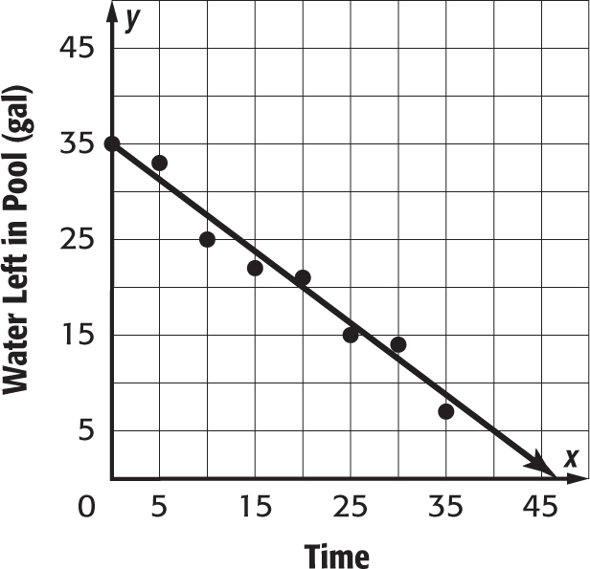

3. Write an equation in slope-intercept form for the line that is drawn. | 4. Use the equation to make a conjecture about the amount of water left in the pool after 40 minutes.

Lesson 2 Extra Practice
Lines of Best Fit
1. The table below shows attendance at an annual Fourth of July concert.
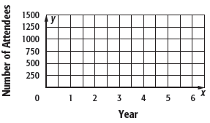
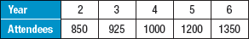
a. Construct a scatter plot of the data. Then draw a line that best represents the data.
b. Write an equation for the line of best fit. Sample answer: y = 112.5x + 625

c. Use the equation to make a conjecture about the number of attendees in the tenth year.
Sample answer: 1,750 attendees

2. The table shows the number of people that attended a family reunion each year.
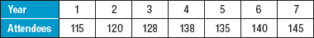
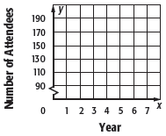
a. Construct a scatter plot of the data. Then draw a line that best represents the data.
b. Write an equation for the line of best fit.
Sample answer: y = 5x + 110

c. Use the equation to make a conjecture about the number of people that might attend the reunion in the fifteenth year.
Sample answer: 185 attendees

