Lesson 3 Skills Practice

Two-Way Tables

For Exercises 1 and 2, construct a two-way table summarizing each set of data.

1. There are 195 male and 126 female students at McGuffey Junior High. A survey showed that 110 males and 84 females ride the bus.
 | Bus | Not Bus | Total
Males
Females
Total

2. The two-way table shows the enrollment in language classes at Carson Middle School. Find and interpret the relative frequencies of students in the survey by row. Round to the nearest hundredth if necessary.

 | Spanish | Not Spanish | Total
Chinese | 30 | 65 | 95
Not Chinese | 20 | 5 | 25

3. Refer to the table in Exercise 2. Find and interpret the relative frequencies of students in the survey by column. Round to the nearest hundredth if necessary.

 | Spanish | Not Spanish
Chinese | 30 | 65
Not Chinese | 20 | 5
Total | 50 | 70

Lesson 3 Homework Practice

Two-Way Tables

For Exercises 1-6, use the Venn diagram at the right and the information below.
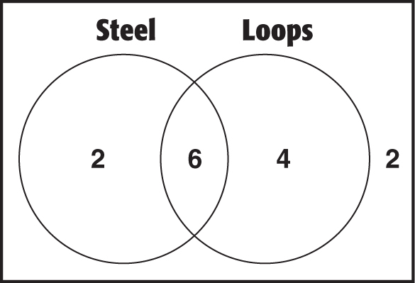

The Venn diagram compares the roller coasters at an amusement park as to whether or not they are made of steel and whether or not they have loops.

1. Complete the two-way table below. 2. How many roller coasters are at the amusement park?
 | Steel | Not Steel | Total
Loops
No Loops
Total

3. Find the relative frequencies from the 4. Interpret the relative frequencies you
table in Exercise 1 by row. found in Exercise 3.
 | Steel | Not Steel | Total
Loops | $\frac{6}{10}= 0.60$
No Loops

5. Find the relative frequencies from the 6. Interpret the relative frequencies you
table in Exercise 1 by column. Round to found in Exercise 5.
the nearest hundredth if necessary.
 | Steel | Not Steel
Loops | $\frac{6}{8}= 0.75$
No Loops
Total

Lesson 3 Problem-Solving Practice

Two-Way Tables

Solve.
 | On  Honor  Roll | Not on  Honor  Roll | Total
Job
No Job
Total

1. Ricardo surveyed 110 eighth grade students to find out if they have a part time job. There are 60 students who have a part-time job, including 48 honor roll students. Half of the students who do not have a job are on the Honor Roll. Construct a two-way table summarizing the data.

Customers entering a store were asked what electronic technology they own. The results of the survey are
 | E-Reader | No E-Reader | Total
Laptop | 20 | 8 | 28
No Laptop | 45 | 22 | 67
Total | 65 | 30 | 95

shown at the right. For Exercises 2 and 3, round relative frequencies to the nearest hundredth if necessary.

2. Find and interpret the relative frequencies by row. | 3. Find and interpret the relative frequencies by column.

Lesson 3 Extra Practice
Two-Way Tables
1. Ninety people in a store were asked whether they liked jeans or khakis and whether they liked T-shirts or tank tops. Out of 25 people that liked khakis, 15 liked T-shirts. There were 55 customers that liked T-shirts.
a. Construct a two-way table summarizing the data.
b. Find and interpret the relative frequencies of people in the survey by columns. Sample answer: y = 112.5x + 625

 | T-Shirts | Tank Tops | Total
Jeans | 40; 0.73 | 25; 0.71 | 65
Khakis | 15; 0.27 | 10; 0.29 | 25
Total | 55; 1.00 | 35; 1.00 | 90

Sample answer: Most people in the store prefer jeans and T-shirts.

Sample answer: 1,
750 attendees
2. One hundred and fifty people were asked whether they liked to see comedies or dramas and whether or not they buy popcorn for the movie. Out of 90 people that liked comedies, 75 said they buy popcorn. There were 40 people that said they do not buy popcorn.
a. Construct a two-way table summarizing the data.
b. Find and interpret the relative frequencies of people in the survey by rows. Sample answer: y = 112.5x + 625
 | Popcorn | No Popcorn | Total
Comedy | 75; 0.83 | 15; 0.17 | 90; 1.00
Drama | 35; 0.58 | 25; 0.42 | 60; 1.00
Total | 110; 0.73 | 40; 0.27 | 150

