Lesson 6 Skills Practice

Analyze Data Distributions

1. AGES The graph shows the ages of people in a play.
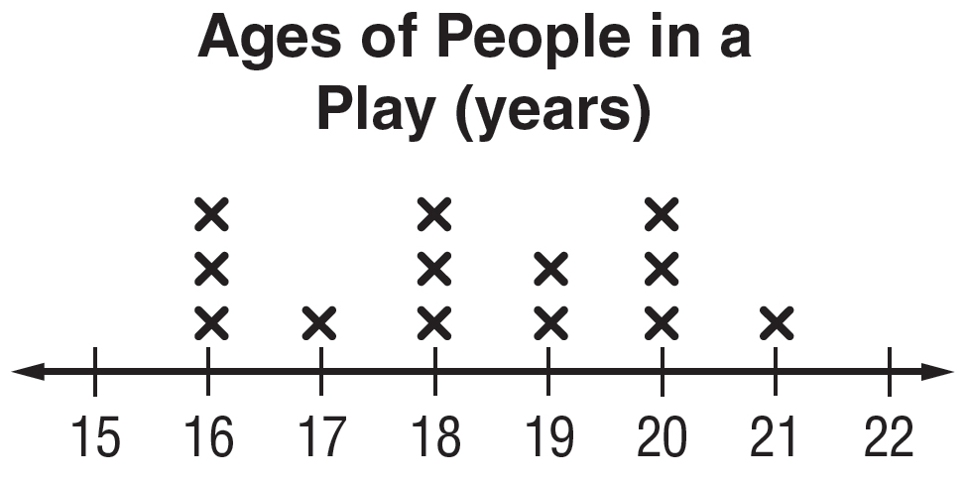

a. Describe the shape of the distribution. Identify any clusters, gaps, peaks, or outliers.

b. Describe the center and spread of the distribution. Justify your response based on the shape of the distribution.

2. SCIENCE The graph shows the lengths of tadpoles in a small puddle.
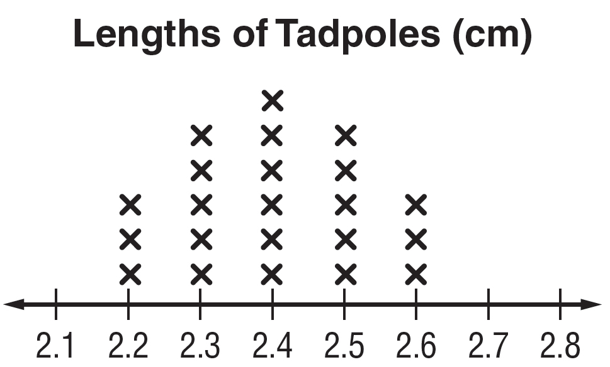
a. Describe the shape of the distribution. Identify any clusters, gaps, peaks, or outliers.

b. Describe the center and spread of the distribution. Justify your response based on the shape of the distribution.

Lesson 6 Homework Practice

Analyze Data Distributions
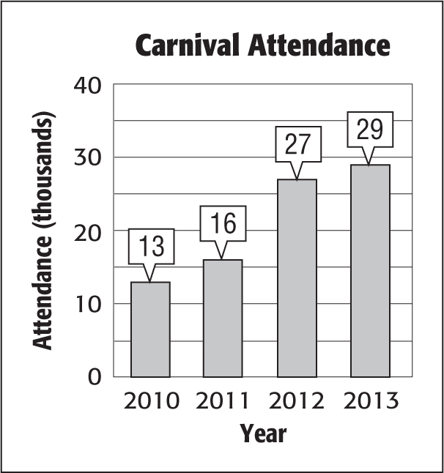
1. CARNIVALS The number of people that attended the carnival each year is shown in the graph at the right.
a. Describe the shape of the distribution. Identify any clusters, gaps, peaks, or outliers.

b. Describe the center and spread of the distribution. Justify your response based on the shape of the distribution.

2. APPLES Mr. Kelly’s homeroom went apple picking. The line plot shows the number of pounds of apples that were collected.
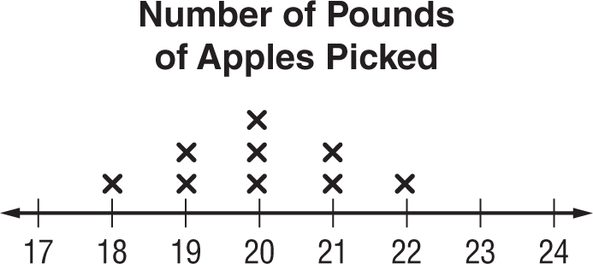
a. Describe the shape of the distribution. Identify any clusters, gaps, peaks, or outliers.

b. Describe the center and spread of the distribution. Justify your response based on the shape of the distribution.

3. TEMPERATURE The line plot shows the high temperatures for various days through the summer.
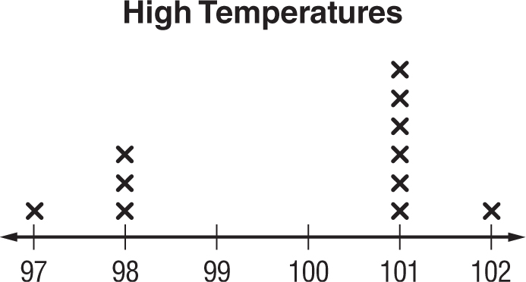
a. Describe the shape of the distribution. Identify any clusters, gaps, peaks, or outliers.

b. Describe the center and spread of the distribution. Justify your response based on the shape of the distribution.

Lesson 6 Problem-Solving Practice

Analyze Data Distributions

FALL The line plot shows the number of restaurants people went to in the past month. Use the information in the line plot to answer Exercises 1 and 2.
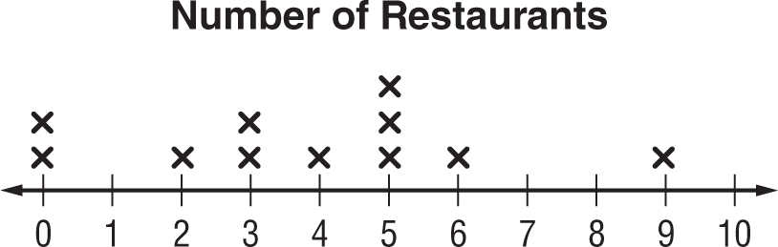

1. Describe the shape of the distribution shown. Identify any clusters, gaps, peaks, or outliers. | 2. Describe the center and spread of the distribution. Justify your response based on the shape of the distribution.
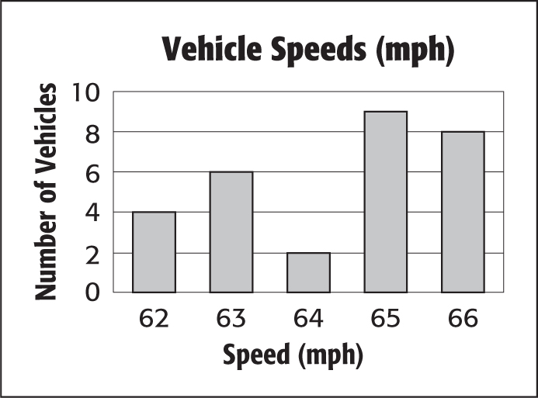
SPEED The graph shows the speeds of several vehicles traveling down a highway. Use the information in the graph to answer Exercises 3 and 4.

1. Describe the shape of the distribution shown. Identify any clusters, gaps, peaks, or outliers. | 2. Describe the center and spread of the distribution. Justify your response based on the shape of the distribution.

Lesson 6 Extra Practice
Analyze Data Distributions
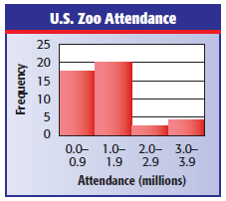
1. The histogram shows the attendance at major U.S. zoos in a recent year. Describe the shape of the distribution shown. Identify any clusters, gaps, peaks, or outliers.
The distribution is not symmetric. There is a cluster from 0.0–1.9 and a peak at the interval 1.0-1.9. There are no gaps or outliers.

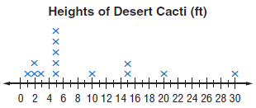
2. The line plot shows the height of desert cacti.
a. Describe the shape of the distribution shown. Identify any clusters, gaps, peaks, or outliers.
The distribution is not symmetric. There is a cluster from 1–5 and a peak at 5. The distribution has a gap from 20–30 feet. There are no outliers.

b. Describe the center and spread of the distribution. Justify your response based on the shape of the distribution.
The distribution is not symmetric, so the median and interquartile range are appropriate measures to use. The data are centered around the median of 5. The spread of the data around the center is 12.

