Chapter 9 Practice Test SCORE ______________

Write the letter for the correct answer in the blank at the right of each question.

1. Consider the equation y = $x^{2}$ + 3x – 4. Determine whether the function has a maximum
or minimum value. State the maximum or minimum value. What are the domain and
range of the function?

2. What is the equation of the axis of symmetry and the coordinates of the vertex of y = $x^{2}$ + 6x – 7?

3. Find the coordinates of the vertex of the graph of y = 4 – $x^{2}$. Identify the vertex as a maximum or a minimum.

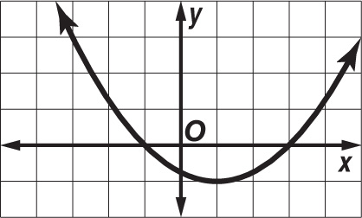
4. What are the roots of the quadratic equation whose related
function is graphed at the right?

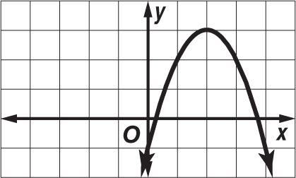
5. One root of the quadratic equation whose related function is
graphed lies between which two consecutive integers?
A 1 and 2 C 0 and –1
B 2 and 3 D 0 and 1

6. What is the general equation to the graph shown?

7. Describe how the graph of the function g(x) = –3$x^{2}$ – 2 is
related to the graph of the function f(x) = $x^{2}$.

8. Find the value of c that makes $x^{2}$ – 5x + c a perfect square trinomial.

1. _______________

2. _______________

3. _______________

4. _______________

5. _______________

6. _______________

7. _______________

8. _______________

Chapter 9 Practice Test (continued)

9. Which value of c makes $y^{2}$ + 8y + c a perfect square trinomial?

10. Which equation is equivalent to $2x^{2}$ + 4x – 6 = 0?
F ${(x+1)}^{2}$ = 2 G ${(x-1)}^{2}$ = 4 H ${(x-1)}^{2}$ = 2 J ${(x+1)}^{2}$ = 4

11. Solve the equation 2x² + 3x – 5 = 0 by using the Quadratic Formula.

12. Determine the number of real solutions of y = ${3x}^{2}$ – 8x + 10.

13. Determine the number of real solutions of $n^{2}$ – 5n – 6 = 0.

14. Which step is not performed in the process of solving $r^{2}$ + 8r + 5 = 0 by completing
the square?
A Subtract 5 from each side. C Add 16 to each side.
B Factor $r^{2}$ + 8r. D Take the square root of each side.

15. Solve the equation 12$v^{2}$ – 6 = –v by using the Quadratic Formula.

x | 0 | 1 | 2 | 3
y | 0 | 2 | 8 | 18
16. Look for a pattern in the table of values
to determine which model best describes
the data.
F linear G quadratic H exponential J none of these

17. Which function best models the data in Question 16?
A y = 2x B 2x + 1 C y = 2$x^{2}$ D y = $2^{x}$

18. What is the range of y = | 3x + 1 |? (fair warning- know all characteristics of the graph!)
F {all real num.} G {y | y ≥ 0} H {y | y ≥ 1} J $\left\{y | y ≥ \frac{1}{3} \right\}$

Bonus ?
9. _______________

10. _______________

11. _______________

12. _______________

13. _______________

14. _______________

15. _______________

16. _______________

17. _______________

18. _______________

B. _______________

