Lesson 1 Reteach

Scatter Plots

A scatter plot shows the relationship between a data set with two variables graphed as ordered pairs.
The pattern of the data points determines the association between the two sets of data.
• Data points that go generally upward from left to right show a positive association.
• Data points that go generally downward from left to right show a negative association.
• Data points with no clear pattern show no association between the data sets.

Examples
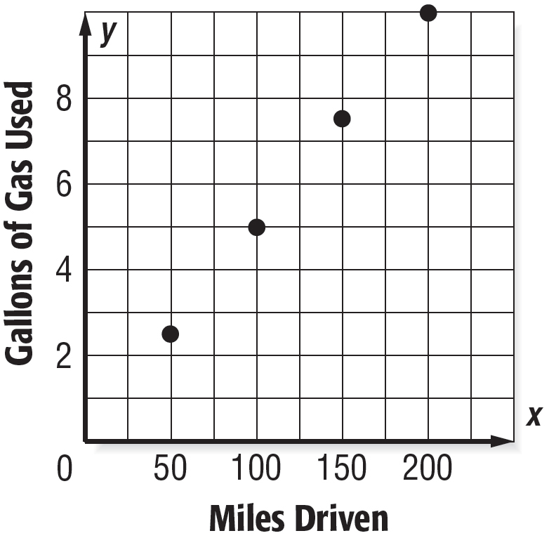
Explain whether the scatter plot of the data shows a positive, negative, or no association. Interpret the scatter plot.

1. miles driven and gallons of gas used

As the number of miles driven increases, the amount of gas used increases. Therefore, the scatter plot will show a positive association. There appears to be a linear association.

2. number of minutes a candle burns and a candle’s height
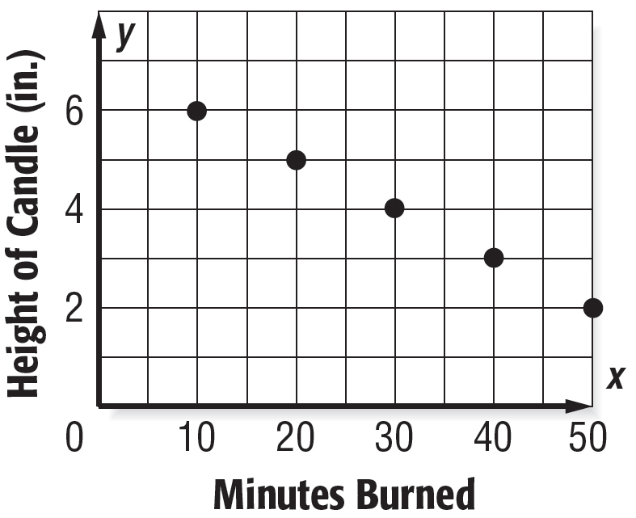

As the number of minutes increases, the height of the candle will decrease. Therefore, the scatter plot will show a negative association. There appears to be a linear association.

Exercises
Explain whether the scatter plot of the data for each of the following shows a positive, negative, or no association. Interpret the scatter plot.

1. 2. 3.
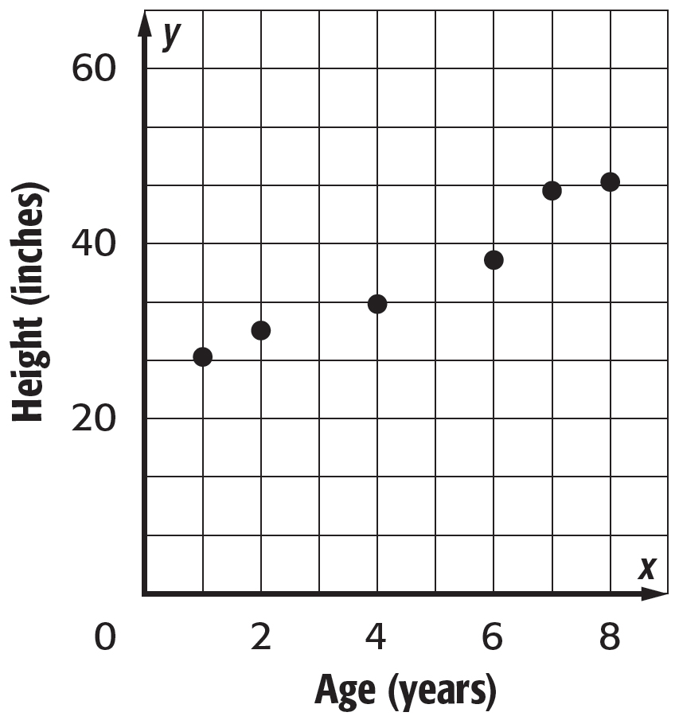
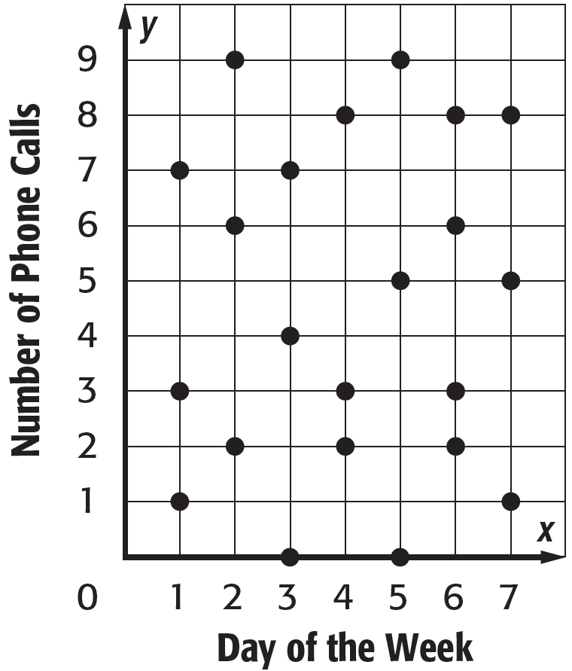
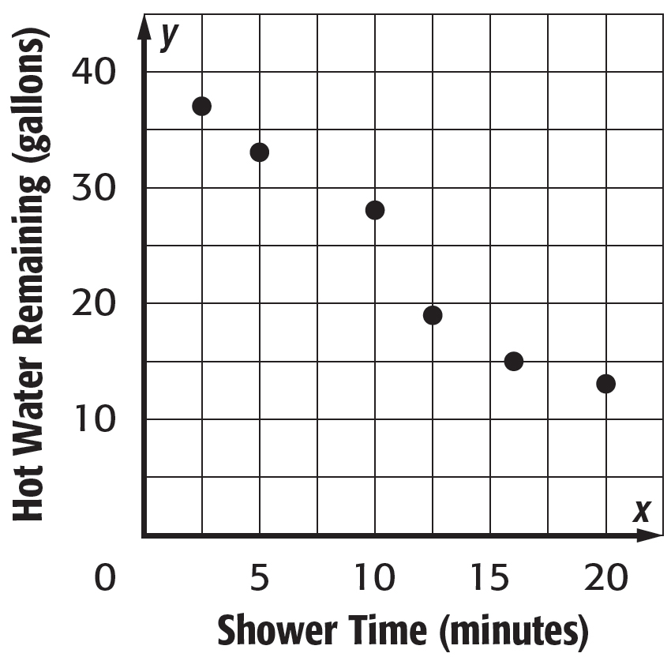

Lesson 2 Reteach

Lines of Best Fit

Examples
BOATS Boat sales at Dustin’s Marina are given.
Week | 1 | 2 | 3 | 4 | 5 | 6 | 7 | 8
Boat Sales | 2 | 3 | 5 | 8 | 6 | 10 | 8 | 18

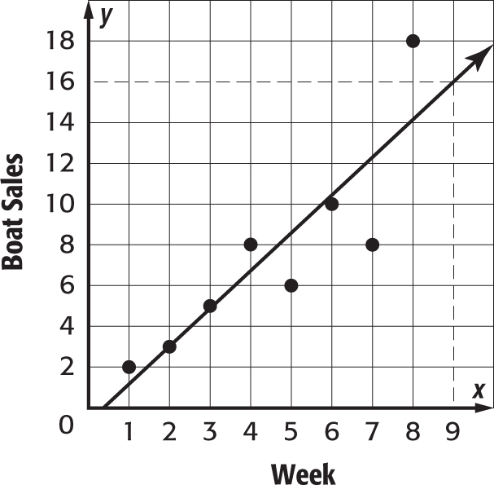
1. Construct a scatter plot using the data. Then draw and assess a line that seems to best represent the data.
Graph each of the data points. Draw a line that fits the data.

2. Use the line of best fit to make a conjecture about boat sales in week 9.
Extend the line so that you can estimate the y-value for an x-value of 9. The y-value for the 9th week is 16 boats. We can predict that Dustin’s Marina will sell 16 boats in week 9.

Exercises
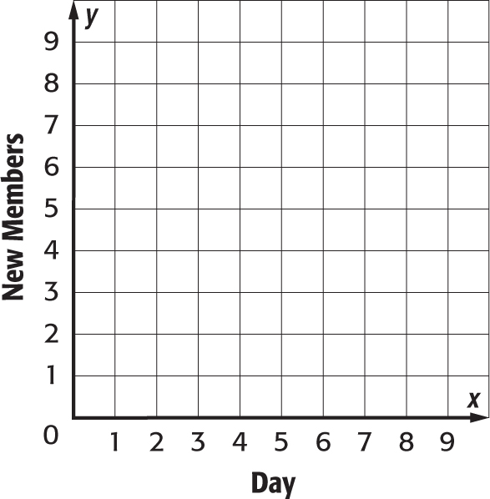

1. OUTDOOR CLUB The table shows the number of new members to join the Outdoor Club.
Day | 1 | 2 | 3 | 4 | 5 | 6
New Members | 3 | 6 | 4 | 3 | 6 | 4

a. Construct a scatter plot of the data. Then draw and assess
a line that seems to best represent the data.

b. Use the line of best fit to make a conjecture about the
number of new members to join the club on the eighth
day.

2. PORTFOLIO The table shows the value of Heather’s portfolio, in thousands of dollars, at the end of each year.
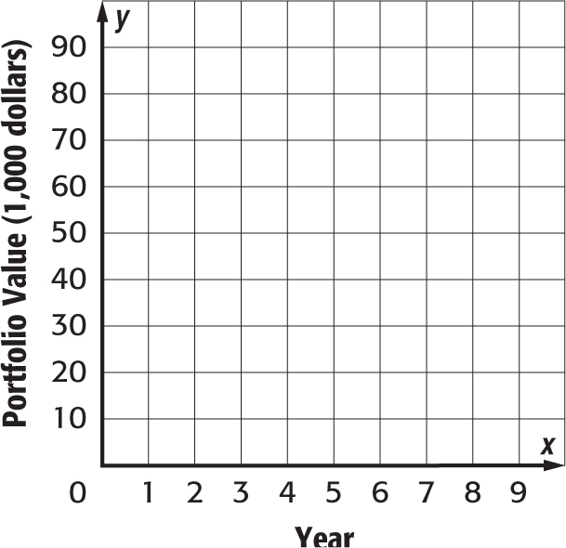
Year | 1 | 2 | 3 | 4 | 5 | 6
Value | 90 | 70 | 80 | 60 | 80 | 60

a. Construct a scatter plot of the data. Then draw and assess
a line that seems to best represent the data.

b. Use the line of best fit to make a conjecture about the
value of Heather’s portfolio at the end of year 8.

Lesson 3 Reteach

Two-Way Tables

Example 1
Marisa surveyed students at her school. She found that 30 out of 75 seventh graders buy their lunch. There are 25 out of 76 eighth graders who do not buy their lunch. Construct a two-way table summarizing the data.

Step 1 Create a table using the two-categories: buy lunch and grade level. Fill in the table with the given values.

Step 2 Use reasoning to complete the table. Remember, the totals are for each row and column. The column labeled “Total” should have the same sum as the row labeled “Total.”

 | Buy Lunch | Do Not Buy Lunch | Total
Seventh Graders | 30 | 45 | 75
Eighth Graders | 51 | 5 | 76
Total | 81 | 70 | 151

Example 2
Find and interpret the relative frequencies of seventh graders in the survey from Example 1 by row. Round to the nearest hundredth if necessary.

 | Buy Lunch | Do Not Buy Lunch | Total
Seventh Graders | 30; $\frac{30}{75}$ = 0.40 | 45; $\frac{45}{75}$ = 0.60 | 75; $\frac{75}{75}$ = 1.00
Eighth Graders | 30;$\frac{51}{76}$ $≈$ 0.67 | 25; $\frac{25}{76}$ $≈$ 0.33 | 76;$\frac{76}{76}$ $≈$ 1.00
Total | 81 | 70 | 151

Sample answer: Less than half of the seventh graders and more than half of the eighth graders buy their lunch.

Exercise
Find and interpret the relative frequencies of seventh graders in the survey from Example 1 by column. Round to the nearest hundredth if necessary.

